*Computer networks practical experiments*

**EXPERIMENT NO—1::**

*Aim :* **configuring networks devices using packet racer.**

***Requirments:***

**1.switch/hub-interferecnce btwn two devices.**

**2.end devices-they are the devices through which we can pass msg from one end to other.**

**3.cable-for connection.**

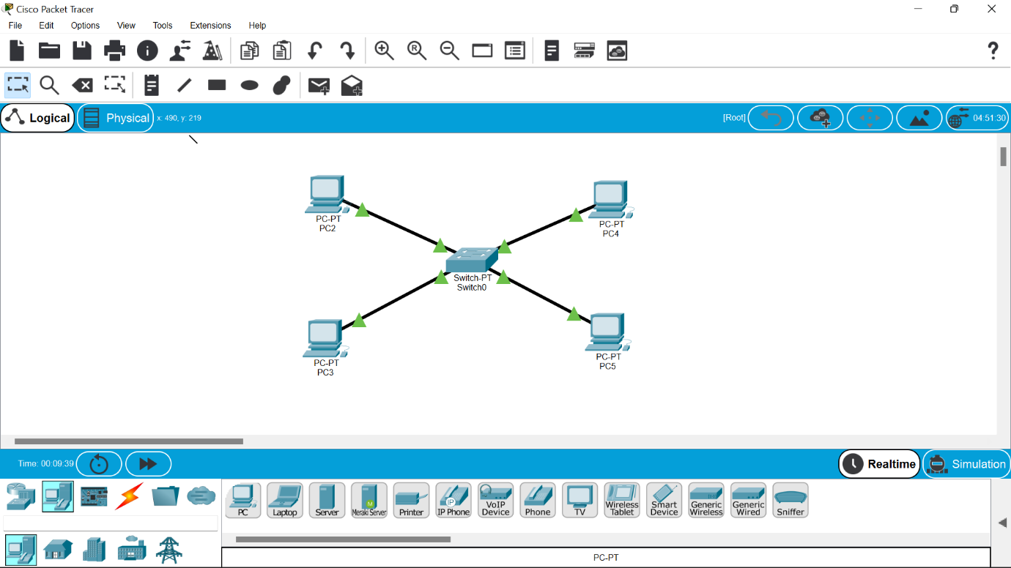

**Four systems are connected to switch using**

**Straight through cable.**

**Ip address will be provided to each system.**

***Procedure:***

**1.The main aim is to configure btwn network devices.**

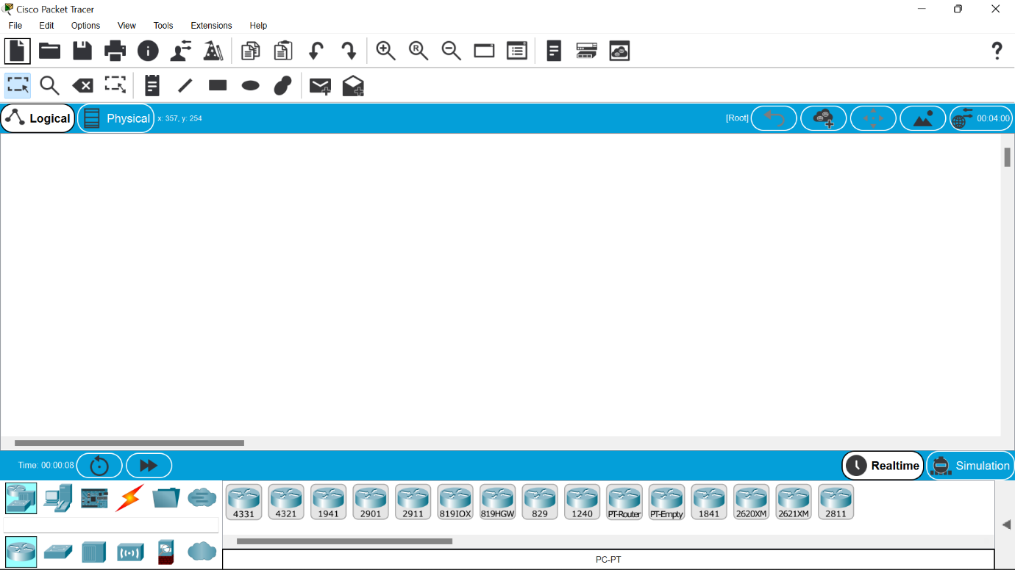

**2.the concept involved in this is ip addressing and address resolution protocol(arp).**

**3.click on the end devices and select pc and drag and drop on the window .**

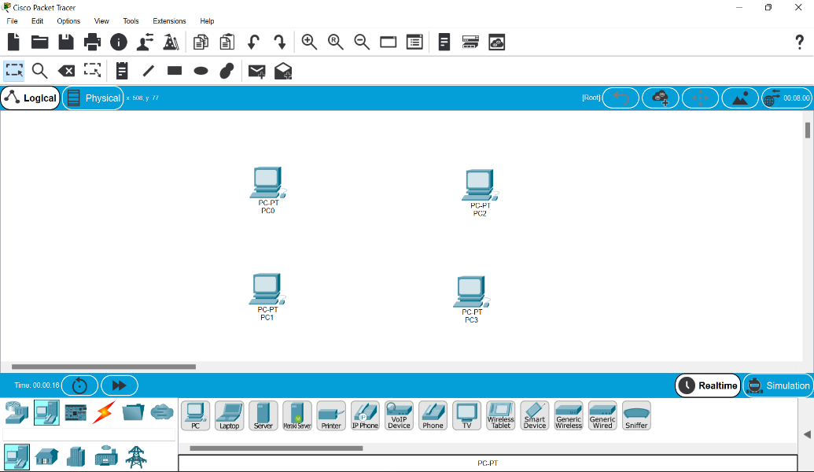

**4.select the switch and drag it and drop it .**

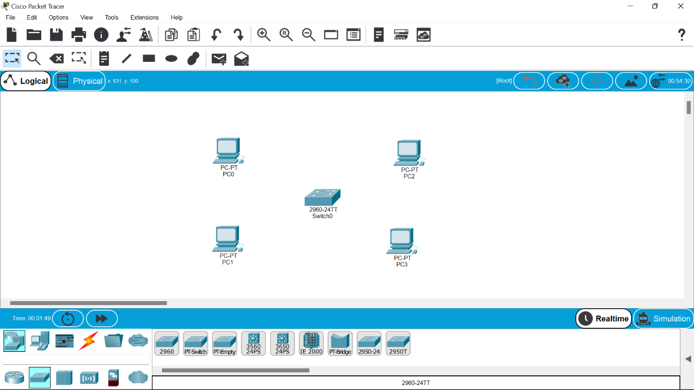

**5.select the straight line through cable and collect all the end devices to switch .**



**6.assign ip address to all the devices .**

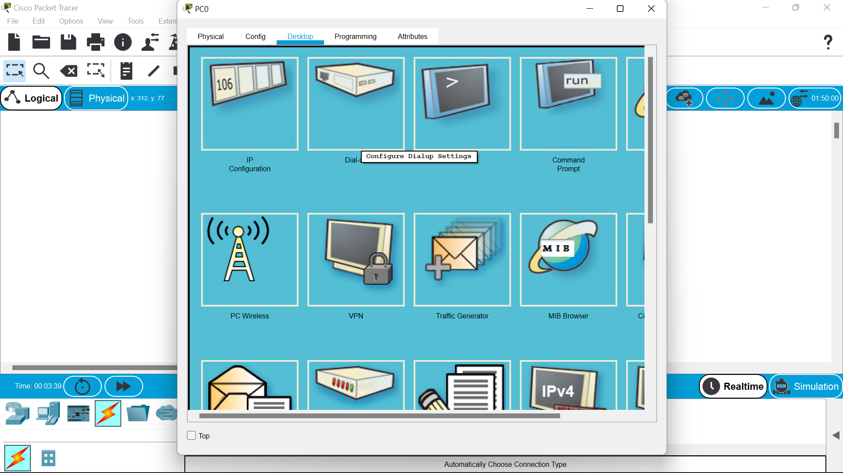

**7.to view the ip address we can go to command prompt and type ipconfigure for each particular.**

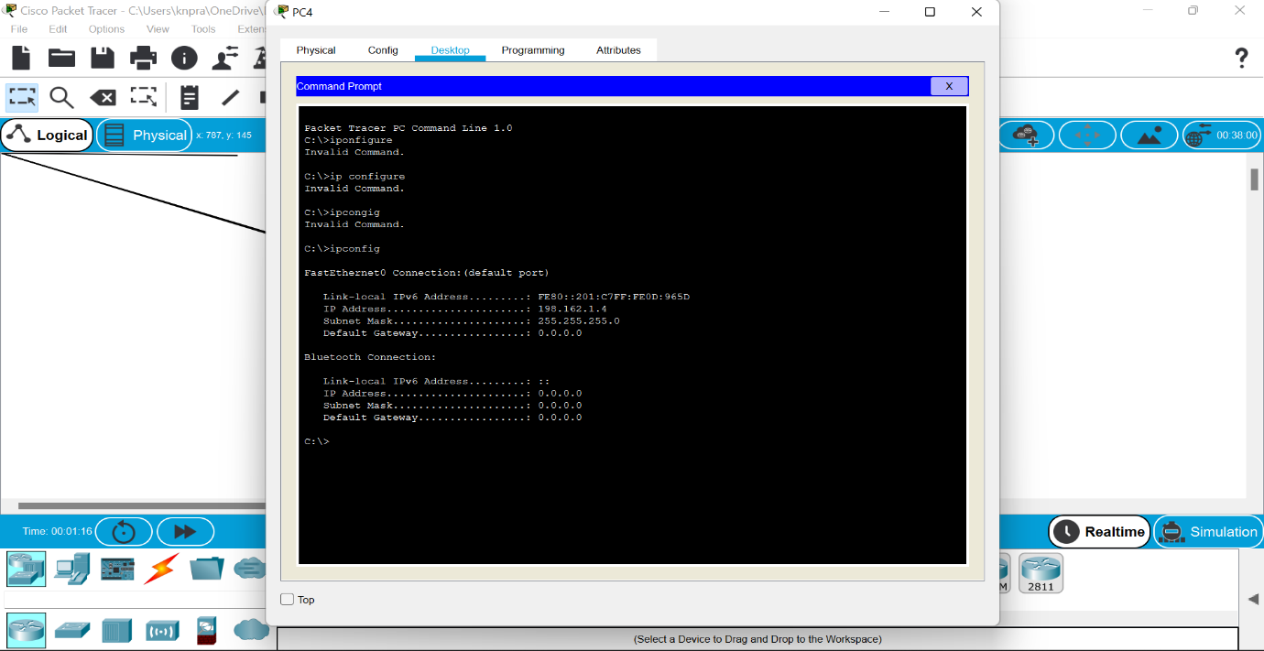

**8.we can also ping command to view the connections btwn devices.**

***Result:***

***Thus the establishment of configuration btwn network device has been done successfully.***

**EXPERIMENT NO—2,3::TOPLOGIES:**

*Aim :*

**Configuration of topologies using packet tracer**

**(bus,star ,ring, mesh,tree,hybrid)**

*Software/Apparatus required:*

Packet Tracer/End devices, bridge, connectors

**Procedure:**

Steps for building topology:

Step 1: Start Packet Tracer

Step 2: Choosing Devices and Connections

Step 3: Building the Topology – Adding Hosts

Step 4: Building the Topology – Connecting the Hosts to Switches

Step 5: Connect PCs to switch by first choosing Connections

Step 6: Configuring IP Addresses and Subnet Masks on the Hosts

Step 7: To confirm Data transfer between the devices

**STAR TOPOLOGY:**

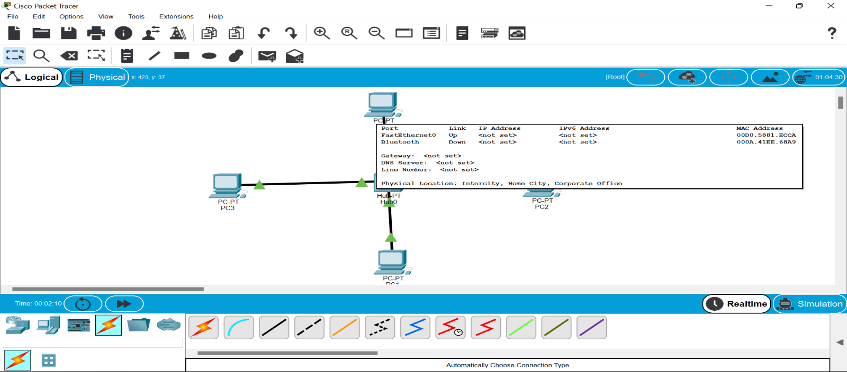

**BUS TOPOLOGY:**

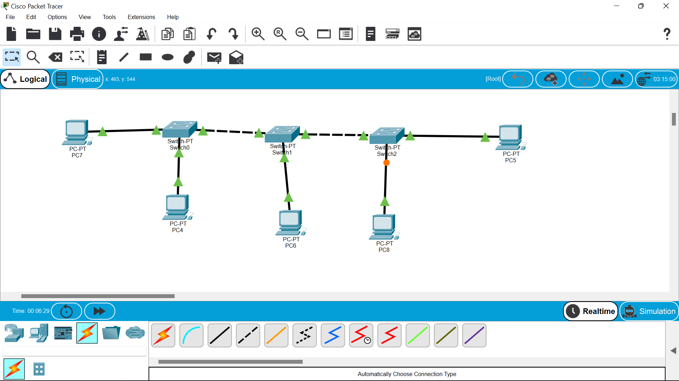

**RING TOPOLOGY:**

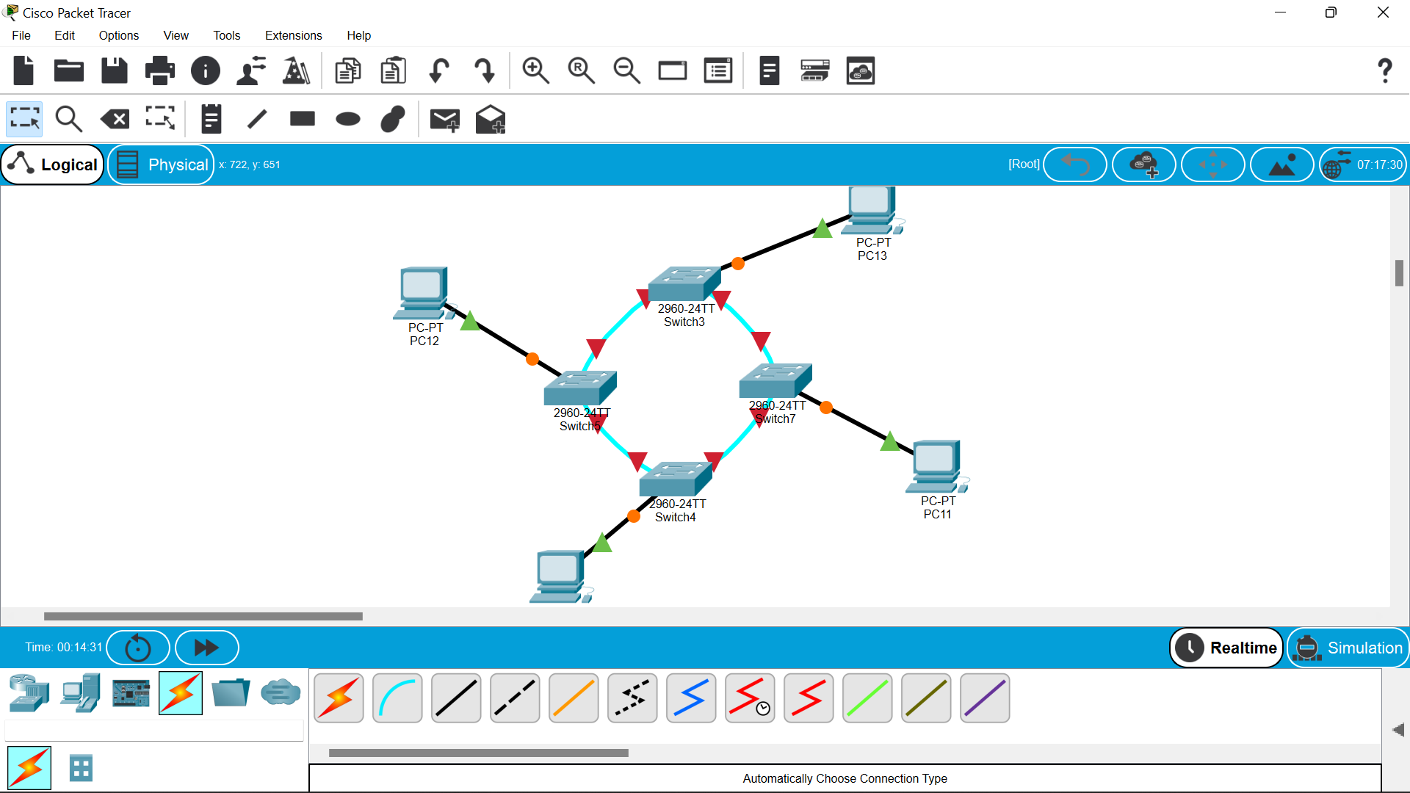

**MESH TOPOLOGY:**

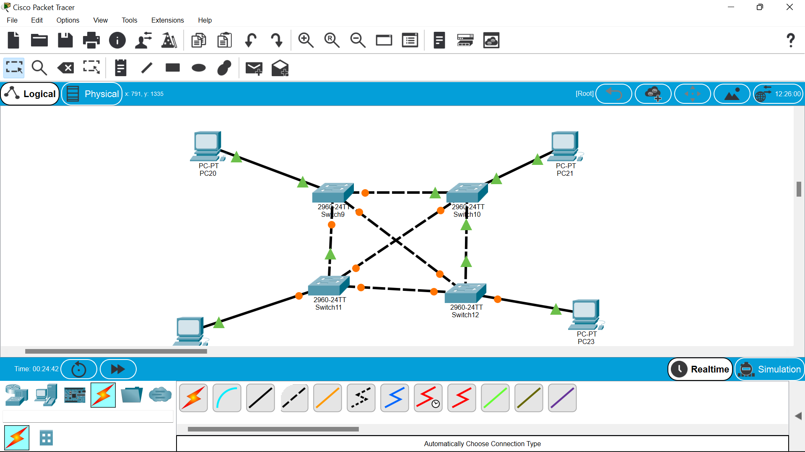

**TREE TOPOLOGY:**

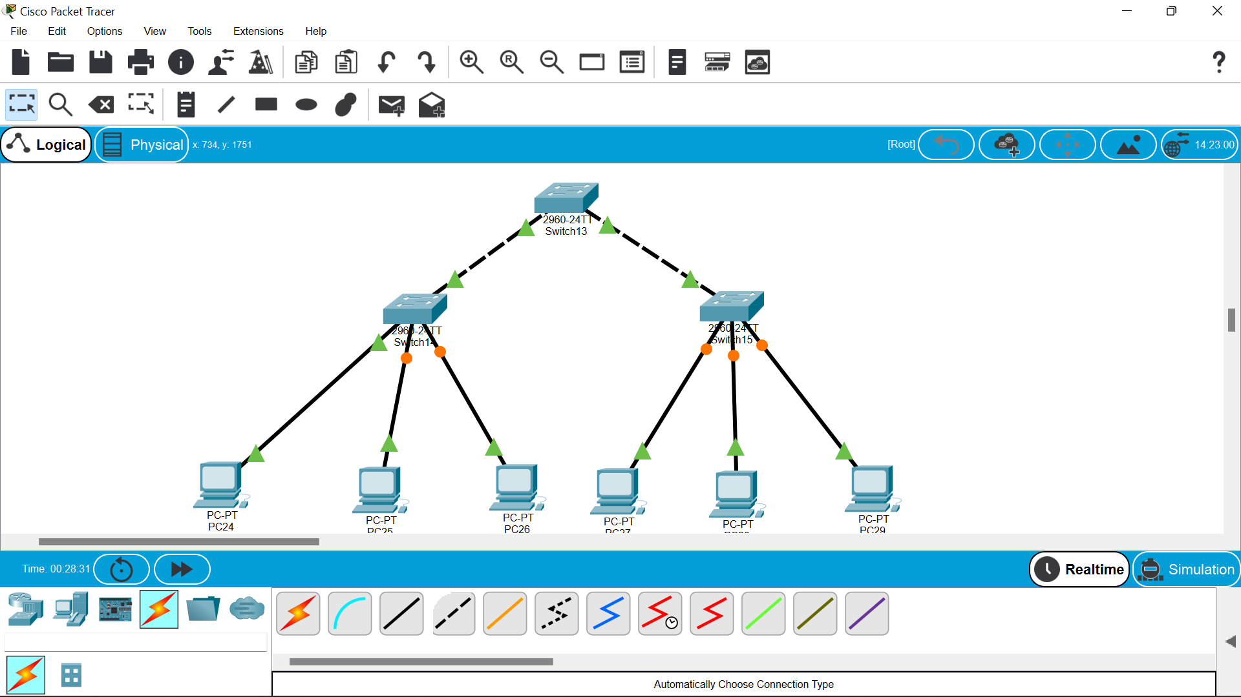

**HYBRID TOPOLOGY:**

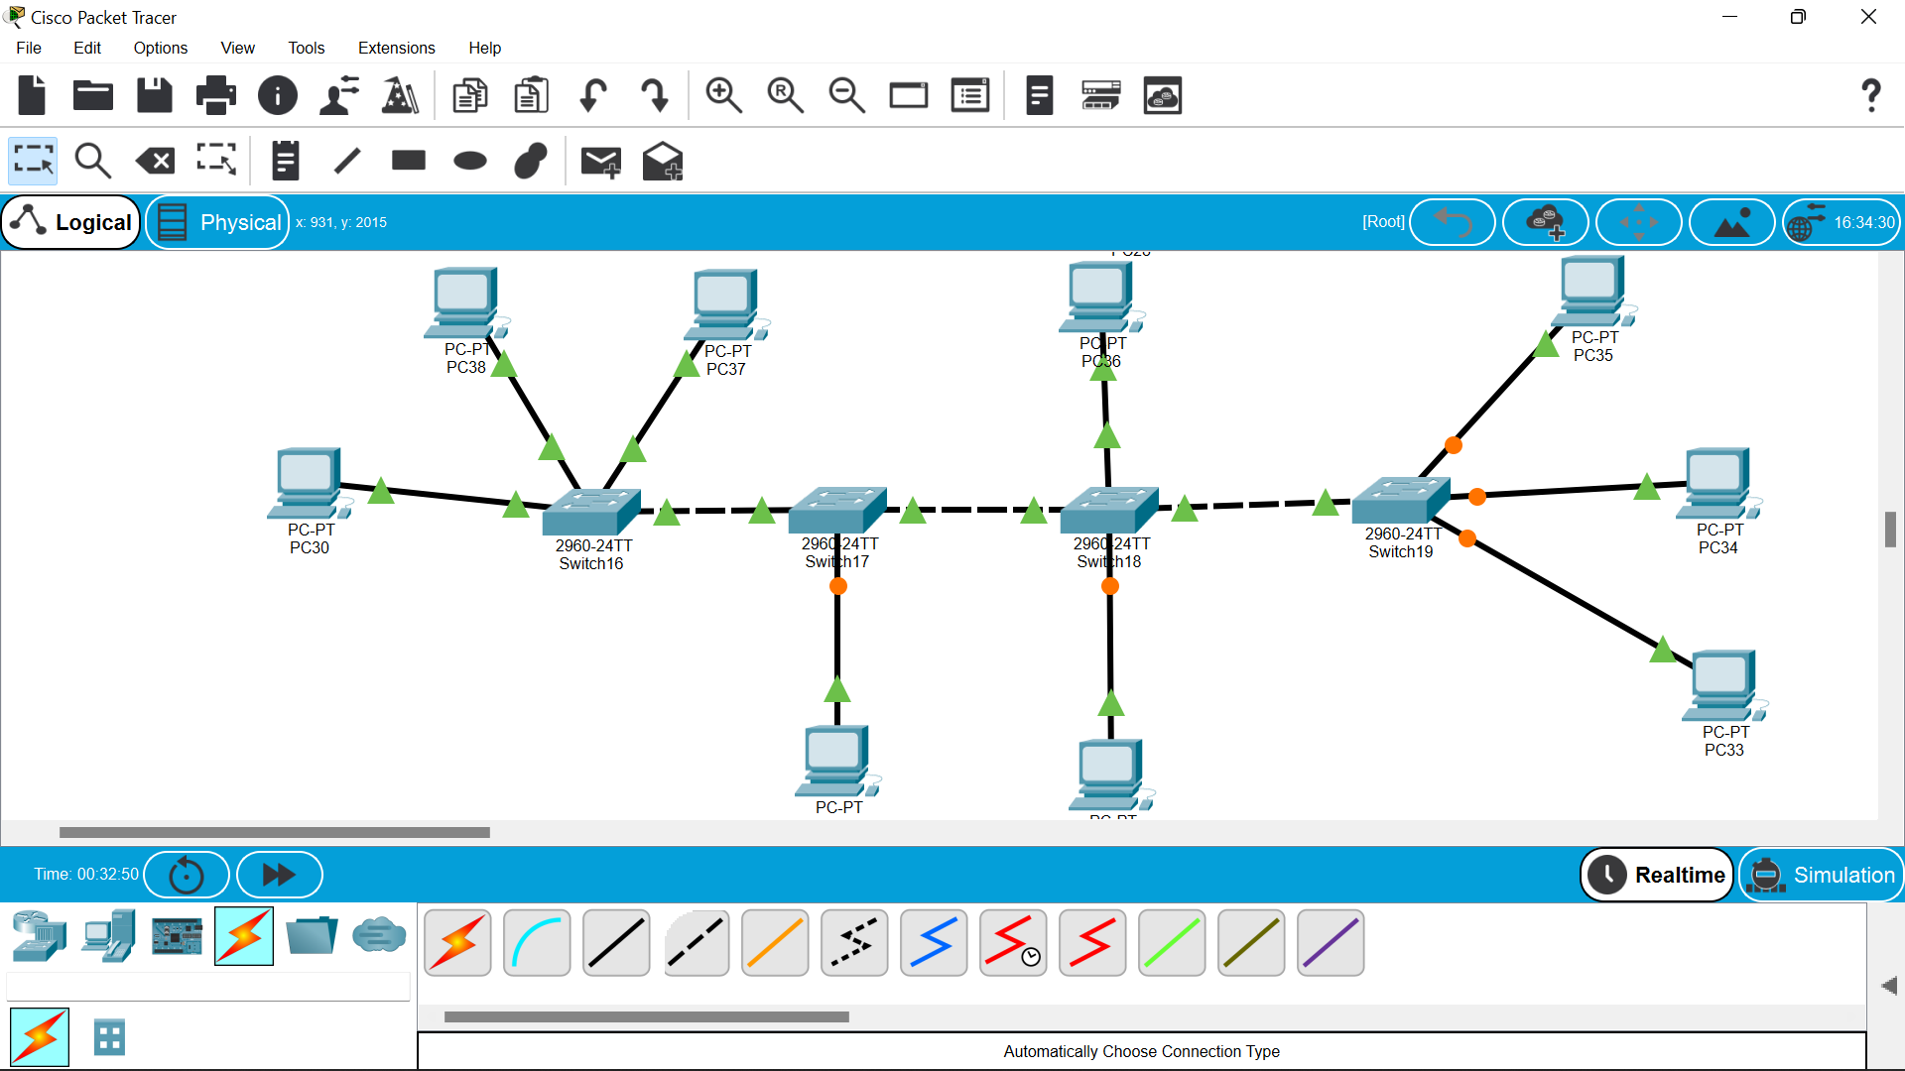

**Result:**

**Thus the configuration of the topologies had been done successfully.**

**EXPERIMENT NO –04:**

**AIM::**

**Data Link Layer Traffic Simulation using Packet Tracer Analysis of ARP**

**REQUIRMENTS::**

**Cisco packet tracer,hubs,switches.**

**PROCEDURE::**

**1.open the cisco tracer and drag the hub to the topology site.**

**2.then drag an two pc’s also on to the site .**

**3.server is also dragged to the work space.**

**4.now arrange them and establish the connections among them as shown below.**

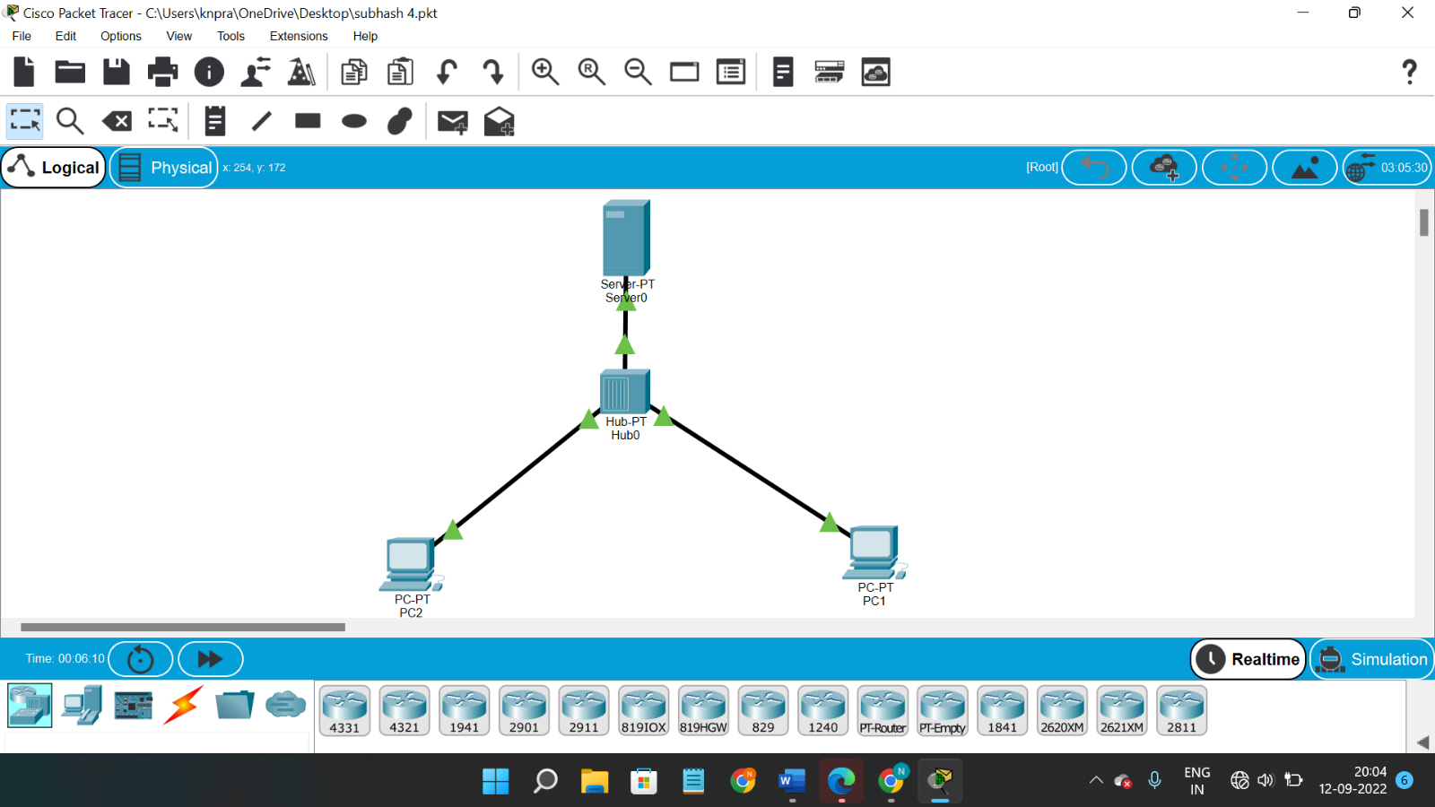

**5.then try to give them the ip address .**

**6.After giving the ip address ,you will find the msg symbol on the top of working space.select it and place on one pc,the select an other pc where you want to send data.**

**7.then start stimulation then you will be able to find the path of transmission of packet.as bellow.**

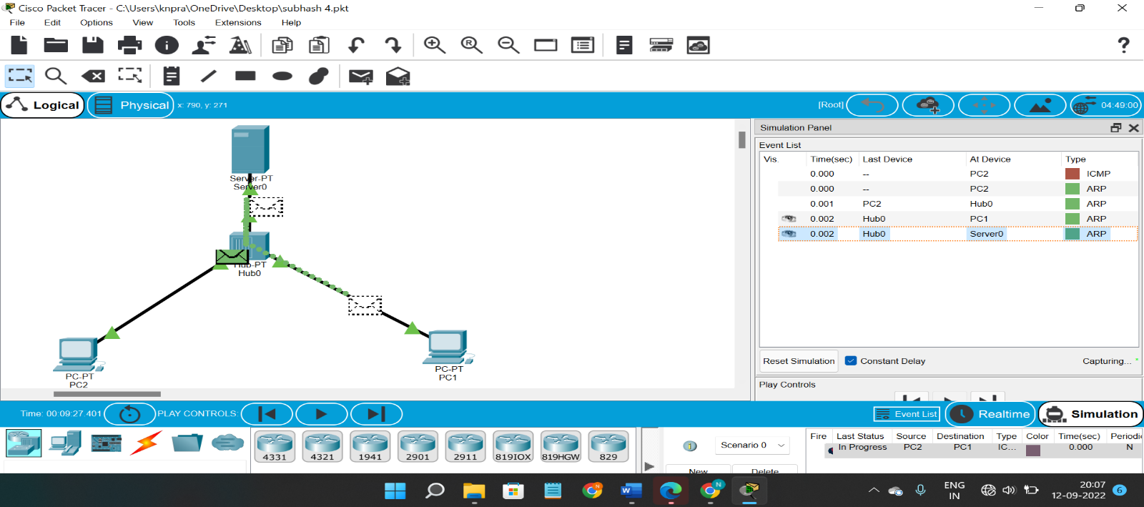

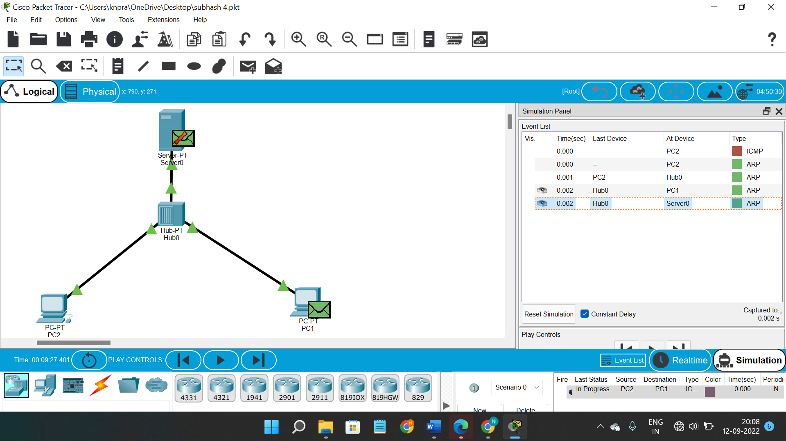

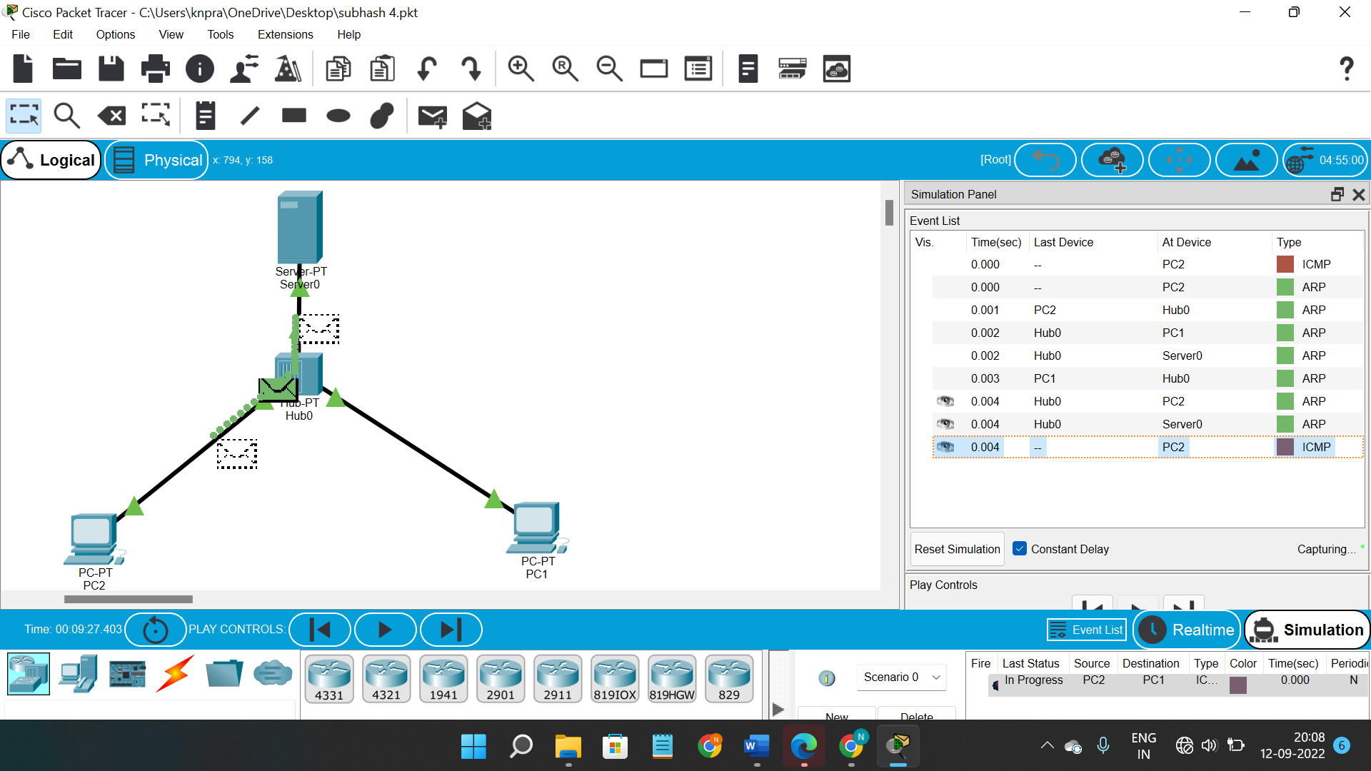

**Result ::**

**So finnaly if you look at the result the msg will be transferred clearly.**

**EXPERIMENT NO –06:**

Configuration of a simple static routing in packet tracer using a simple topology with two routers

**AIM::**

To Configure a router using packet tracer software and hence to transmit data between the devices in real time mode and simulation mode.

Software/Apparatus required:

Packet Tracer/End devices, Hubs, connectors.

Steps for building topology:

Step 1: Start Packet Tracer

Step 2: Choosing Devices and Connections

Step 3: Single click on the End Devices. Single click on the Generic Host. Place PC0, PC1 on topology area. Connect PCs to Switch 1. Similarly Place PC2, PC3 on topology area for receiver side Connect these PCs with switch 1 and 2 respectively through connecting wires. Select 2Routers and place the routers each one upon their switches . Connect these switches into router through connecting wires.

Step 3:Configuring IP Addresses, Gate Way and Subnet Masks on the Hosts

To start communication between the hosts IP Addresses, subnet Masks and Gate way had to be configured on the devices.

Click once on PCs. Choose the Config tab and click on FastEthernet0.

Type the IP address in its field. Based on router create gate way click on the subnet mask. It will be generated automatically.

Step 4: Verifying Connectivity in Realtime Mode Be sure you are in Realtime mode.

Select the Add Simple PDU tool used to ping devices.

Click once on PC0, then once on PC3. The PDU Last Status should show as Successful.

Step 5: Verifying Connectivity in Simulation Mode

Be sure you are in Simulation mode.

Deselect all filters (All/None) and select only ICMP.

Select the Add Simple PDU tool used to ping devices Click once on PC0, then once on PC3.

Continue clicking Capture/Forward button until the ICMP ping is completed.

You should see the ICMP messages move between the hosts, hub and switch.

The PDU Last Status should show as Successful.

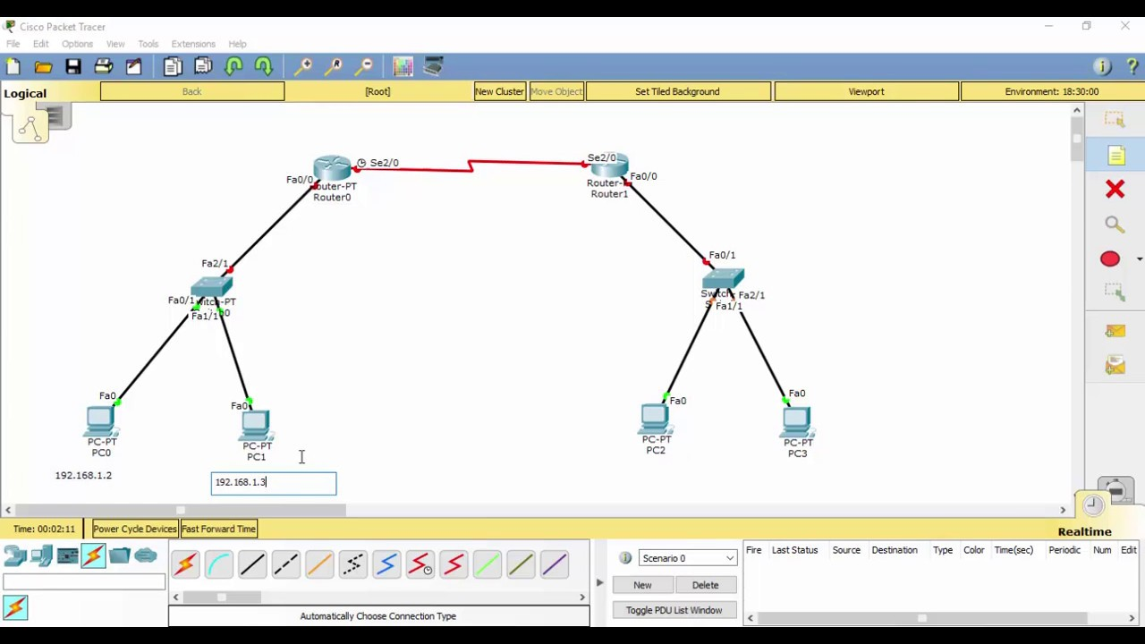

Result:

Thus Configuration of a simple static routing in packet tracer using a simple topology with two routers was done successfully

**EXPERIMENT NO –06:**

**Dynamic Routing using Packet Tracer (Distance vector).**

**AIM::**

To Configure a network using distance vector routing (Routing information protocol) using packet tracer software and hence to transmit data between the devices in real time mode as well as simulation mode.   
Software/Apparatus required:

Packet Tracer/End devices, Hubs, connectors

Steps for building topology:

Step 1: Start Packet Tracer

Step 2: Choosing Devices and Connections

Step 3: Single click on the End Devices. Single click on the Generic Host. Place PC0, PC1 on topology area. Connect PCs to Switch 1. Similarly Place PC2, PC3 on topology area for receiver side. Connect these PCs with switch 1 and 2 respectively through connecting wires. Select Router1 and Router 2 and place the router 1, 2 between two switches. Connect these switches into router through connecting wires.

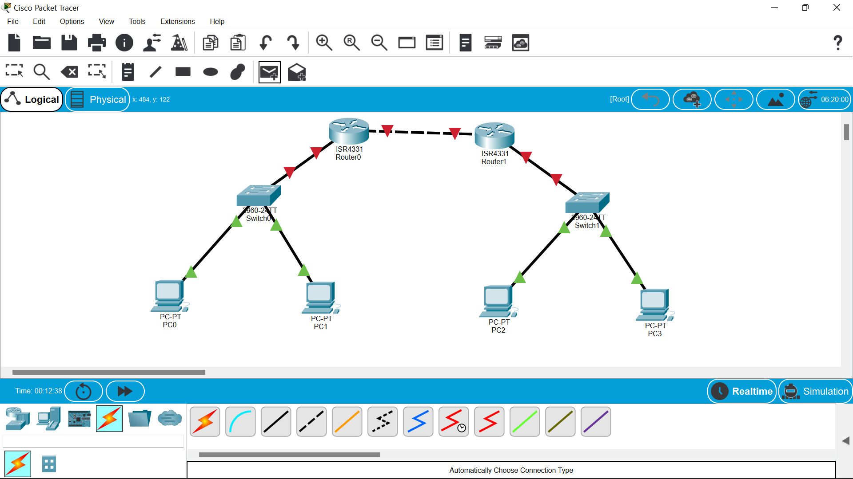

Step 3:Configuring IP Addresses, Gate Way and Subnet Masks on the Hosts

To start communication between the hosts IP Addresses, subnet Masks and Gate way had to be configured on the devices. Click once on PCs. Choose the Config tab and click on FastEthernet0. Type the IP address in its field. Based on router create gate way click on the subnet mask. It will be generated automatically

Step 4: Verifying Connectivity in Realtime Mode Be sure you are in Realtime mode.

Select the Add Simple PDU tool used to ping devices. Click once on PC0, then once on PC3. The PDU Last Status should show as Successful.

Step 5:Verifying Connectivity in Simulation Mode Be sure you are in Simulation mode.

Deselect all filters (All/None) and select only ICMP. Select the Add Simple PDU tool used to ping devices Click once on PC0, then once on PC3. Continue clicking Capture/Forward button until the ICMP ping is completed. You should see the ICMP messages move between the hosts, hub and switch. The PDU Last Status should show as Successful

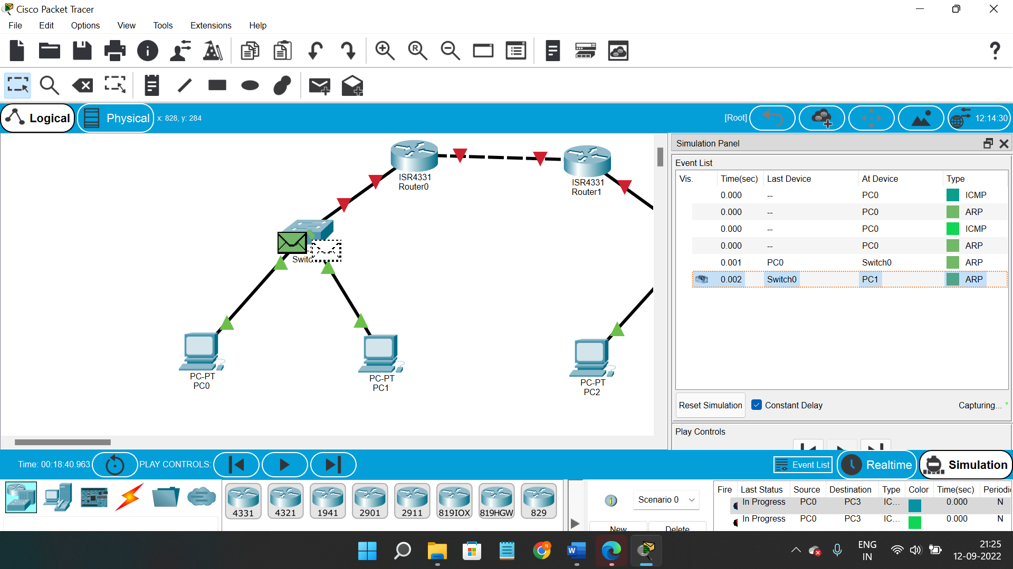

Result: Thus the Configuration of Dynamic Routing – RIP in Packet Tracer.

**EXPERIMENT NO –11:**

**IOT BASED SMART HOME USING CISCO PACKET TRACER.**

**AIM:**

**The main aim is to build an smart home based on the iot systems.**

**Materials required:: Cisco tracer software.**

Procedure ::

1.open the cisco tracer .

2.Then ,network devices-wireless devices-homegateway and place it on the site.

3.then ,end devices—home—celing fan -and windows and other home appliences.

4.then set them as bellow

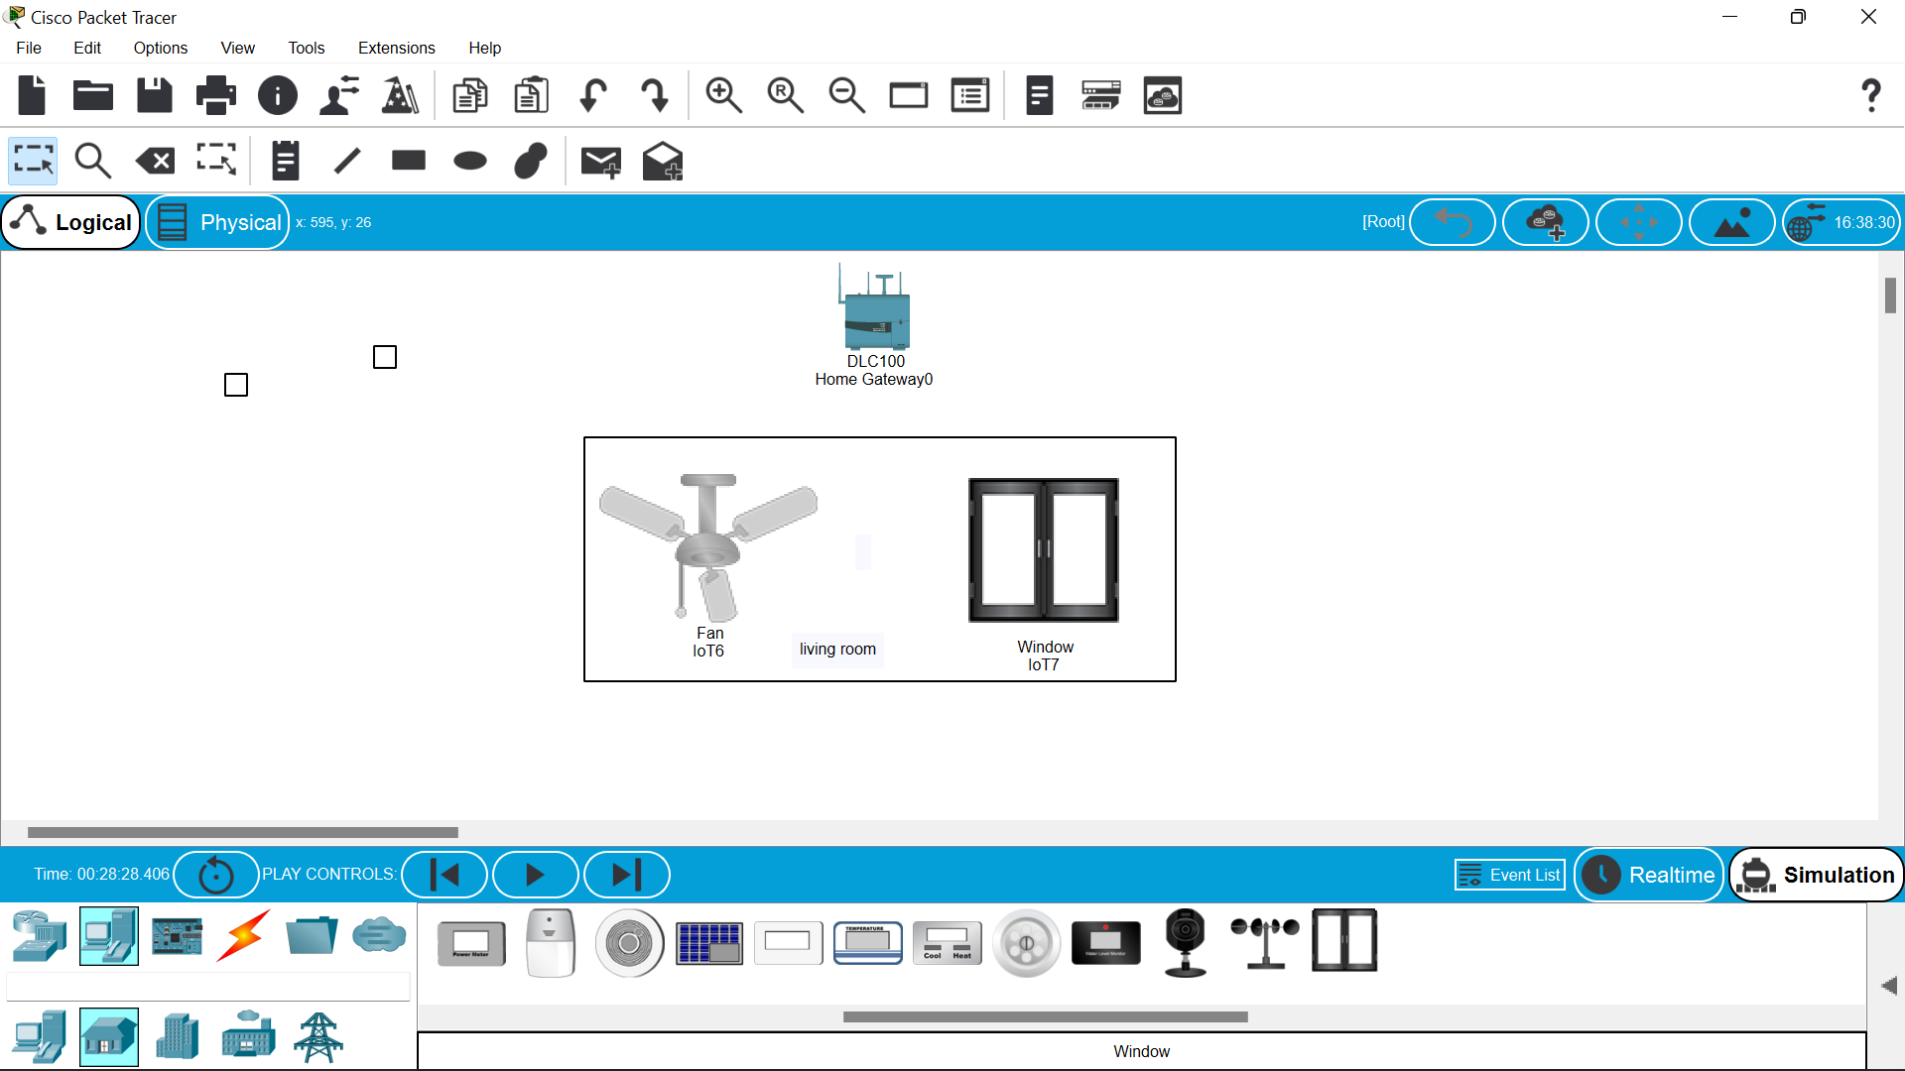

5.then click on the fan -i/o configure –choose the wireless –then configr and wireless0 .repeat the same to the window also.the the dotted lines will be formed btwn the homegatway and fan and window.

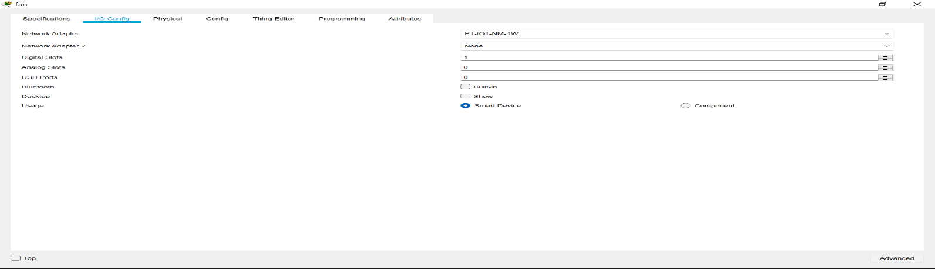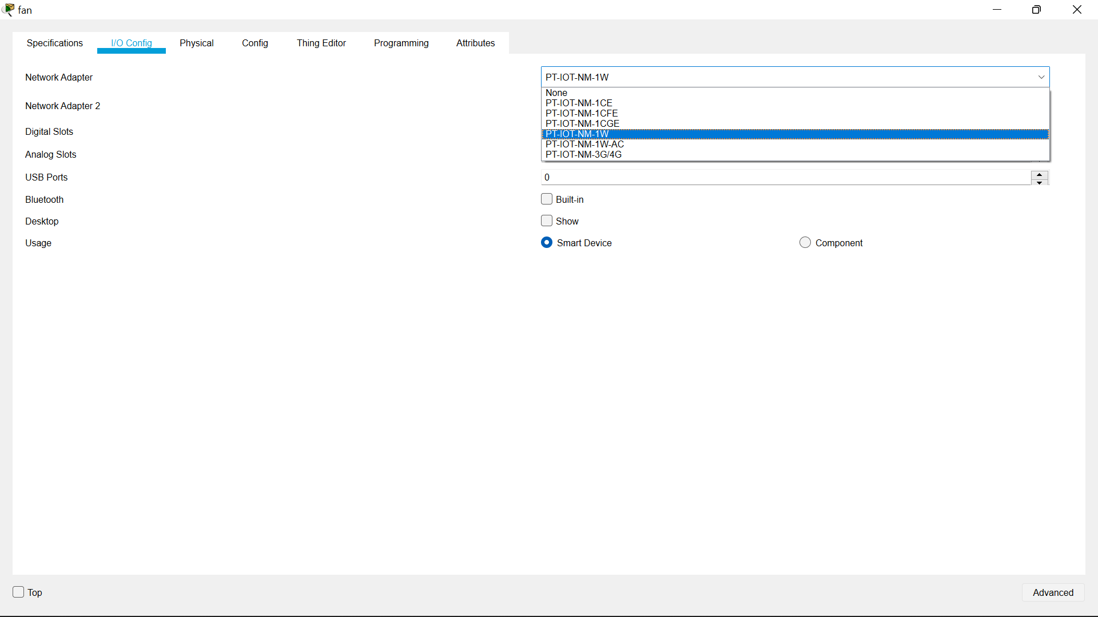

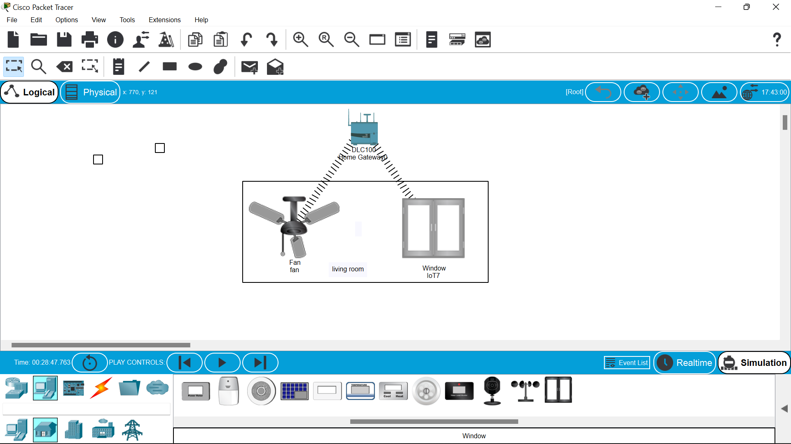

6.Then move to the end devices –click the smartphone to operate the wireless devices.

7.click on the smart phone to configure with homegateway give “HomeGateway” in the ssid space in wireless0.

8.connetion is established.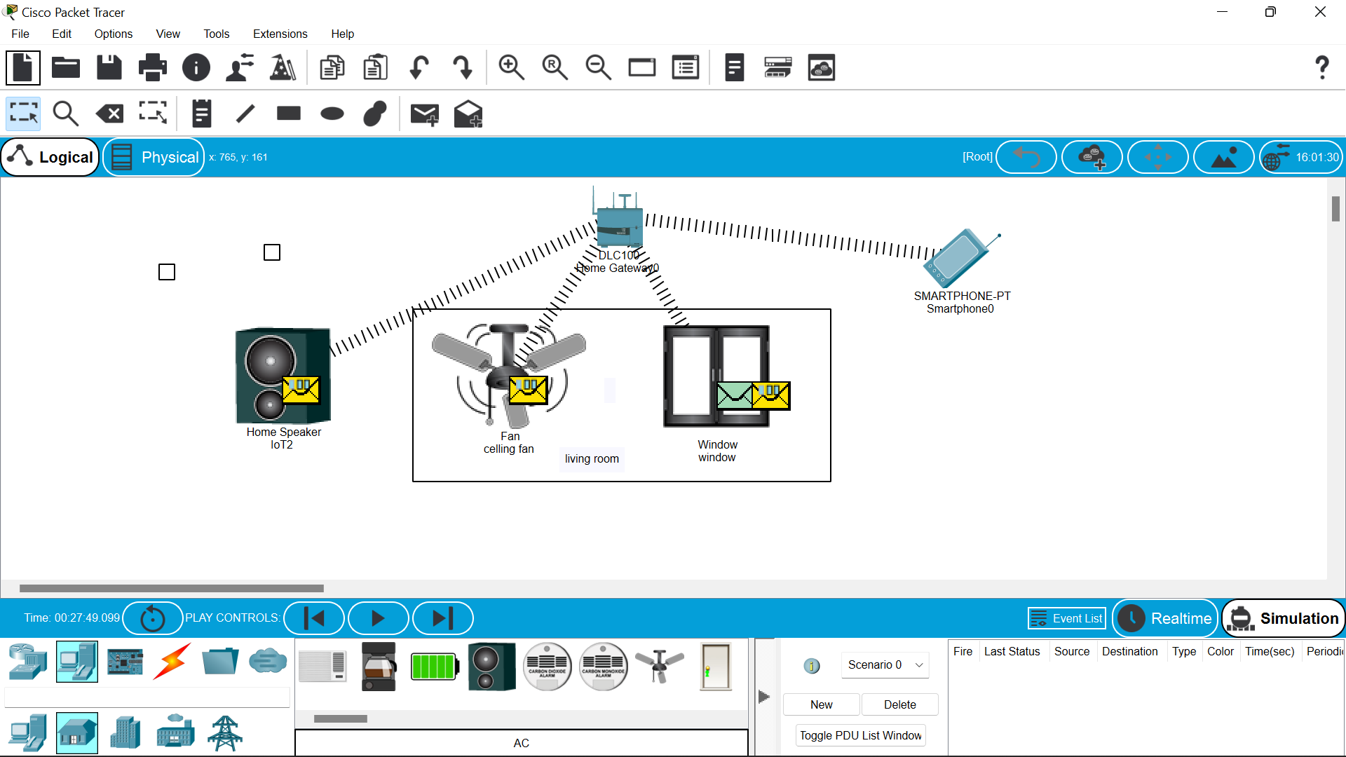

9.then click on the smart phone open desktop –iot monitor—login .10.then you will find switches of celing fan and the window switches .

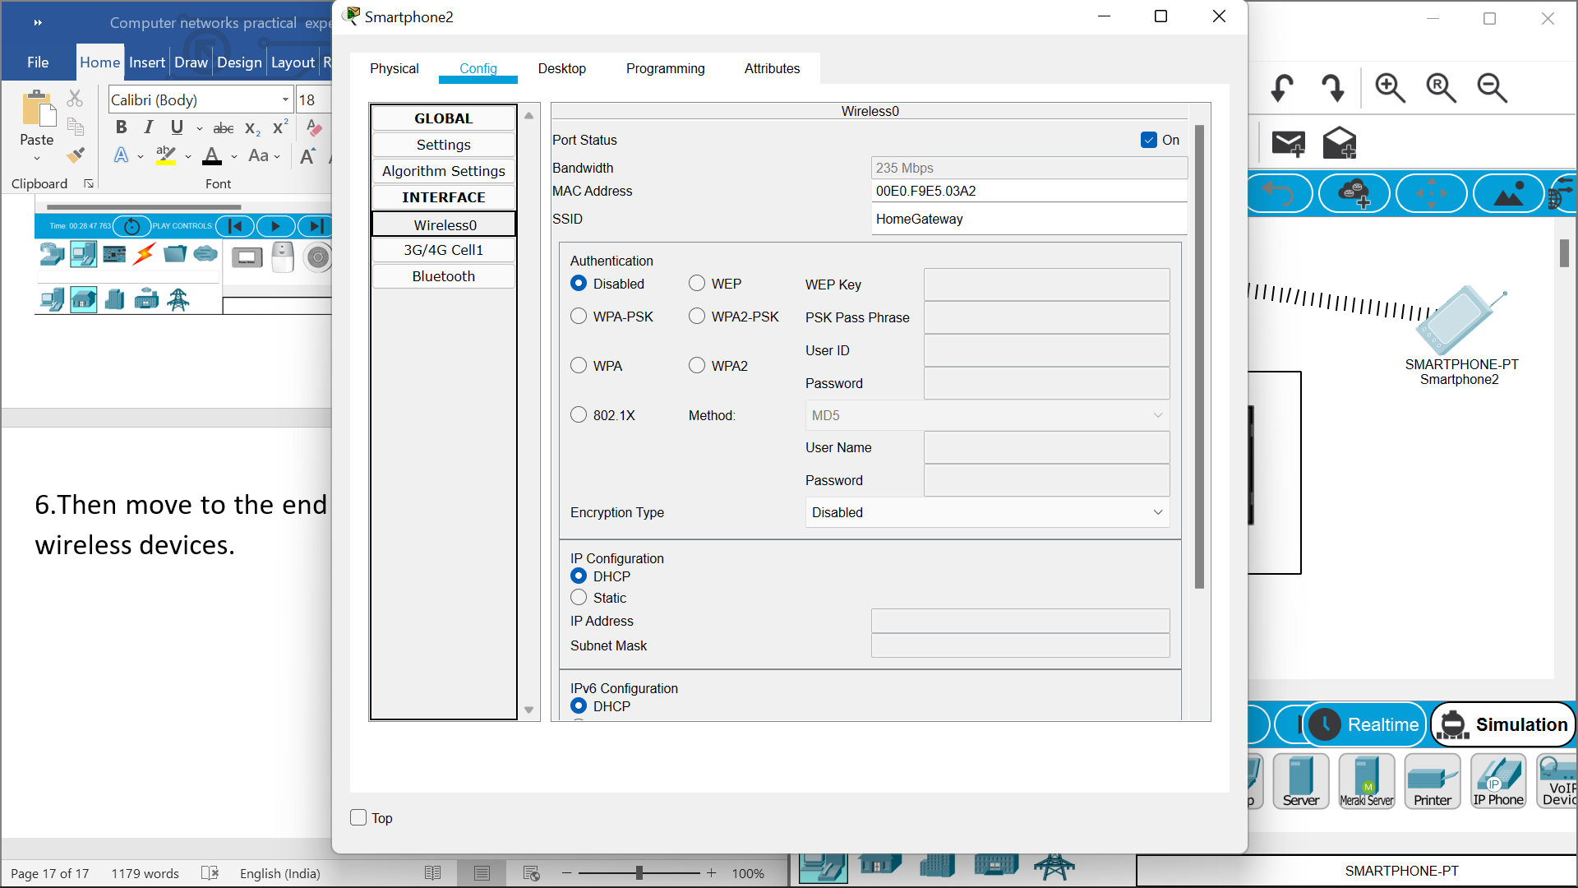

11.below are the switches to access the fan and window.

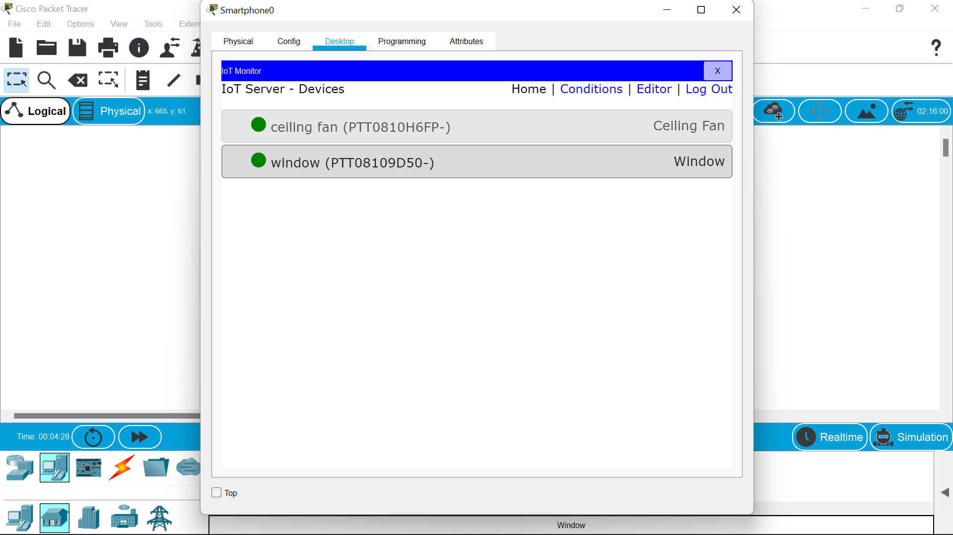.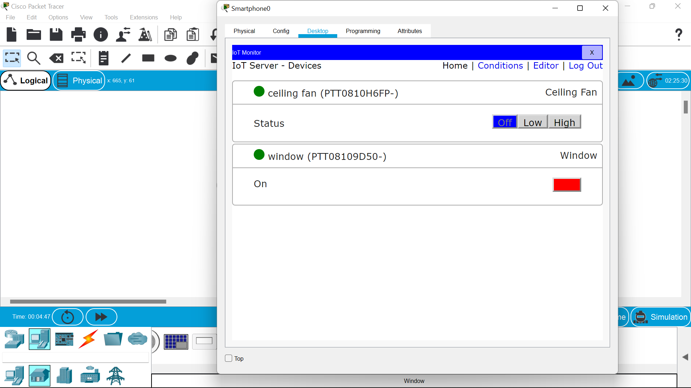

RESULT::

So successfully an iot smart house is made……

**EXPERIMENT NO –12:**

**IOT BASED SMART GARDEN USING CISCO PACKET TRACER.**

**AIM:**

**The main aim is to build an smart graden based on the iot systems.**

**Materials required:: Cisco tracer software,water sprinkler ,water level monitor.**

Procedure ::

1.open the cisco tracer .

2.Then ,network devices-wireless devices-homegateway and place it on the site.

3.then ,end devices—home—lawn sprinkler -and waterlevel monitor and other garden appliences.

4.then set them as bellow

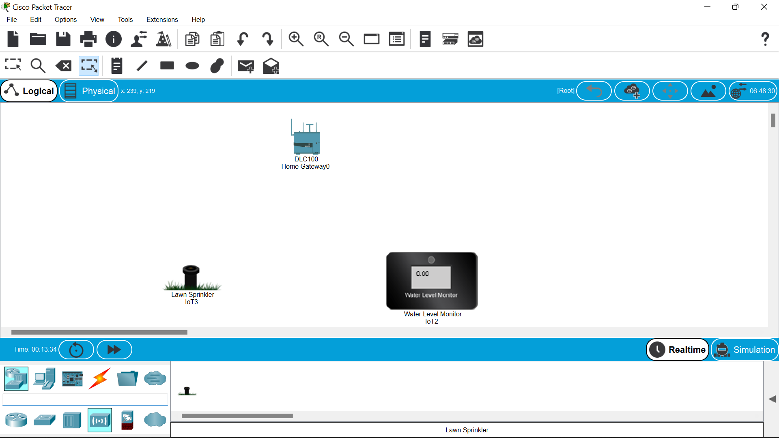

5.then click on the lawn sprinkler-i/o configure –choose the wireless –then configuration and wireless0 .repeat the same to the water level monitor also,then the dotted lines will be formed btwn the homegatway and lawn water sprinkler and water level minotor.

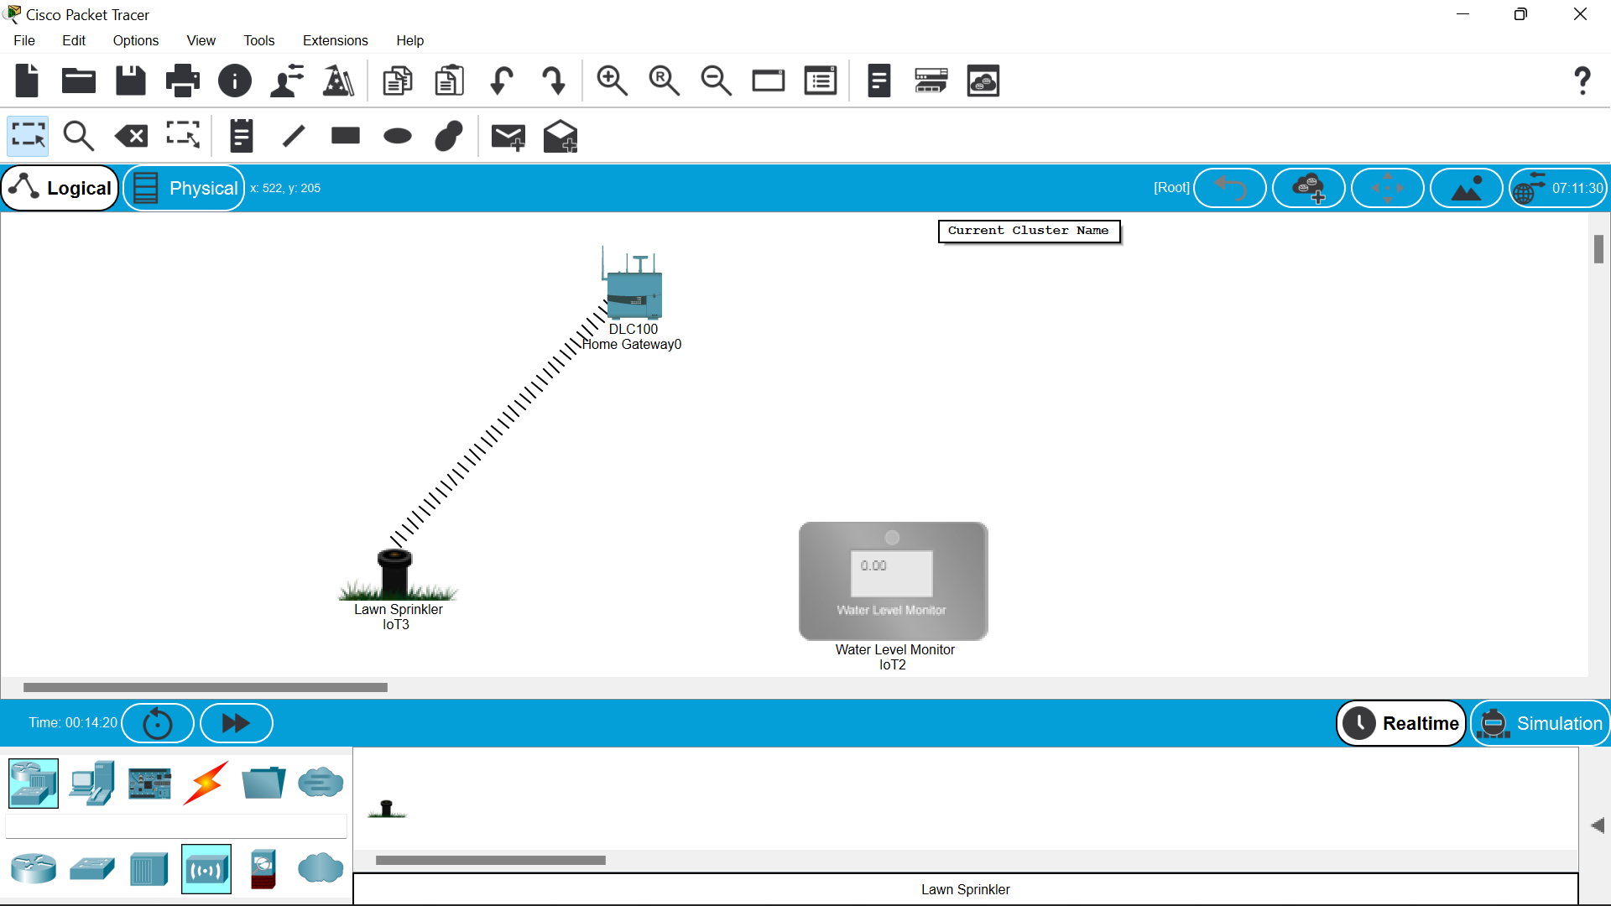

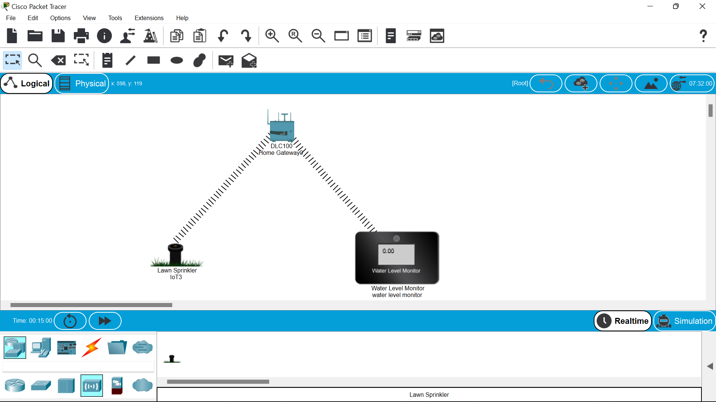

6.Then move to the end devices –click the smartphone to operate the wireless devices.

7.click on the smart phone to configure with homegateway give “HomeGateway” in the ssid space in wireless0.

8.connetion is established 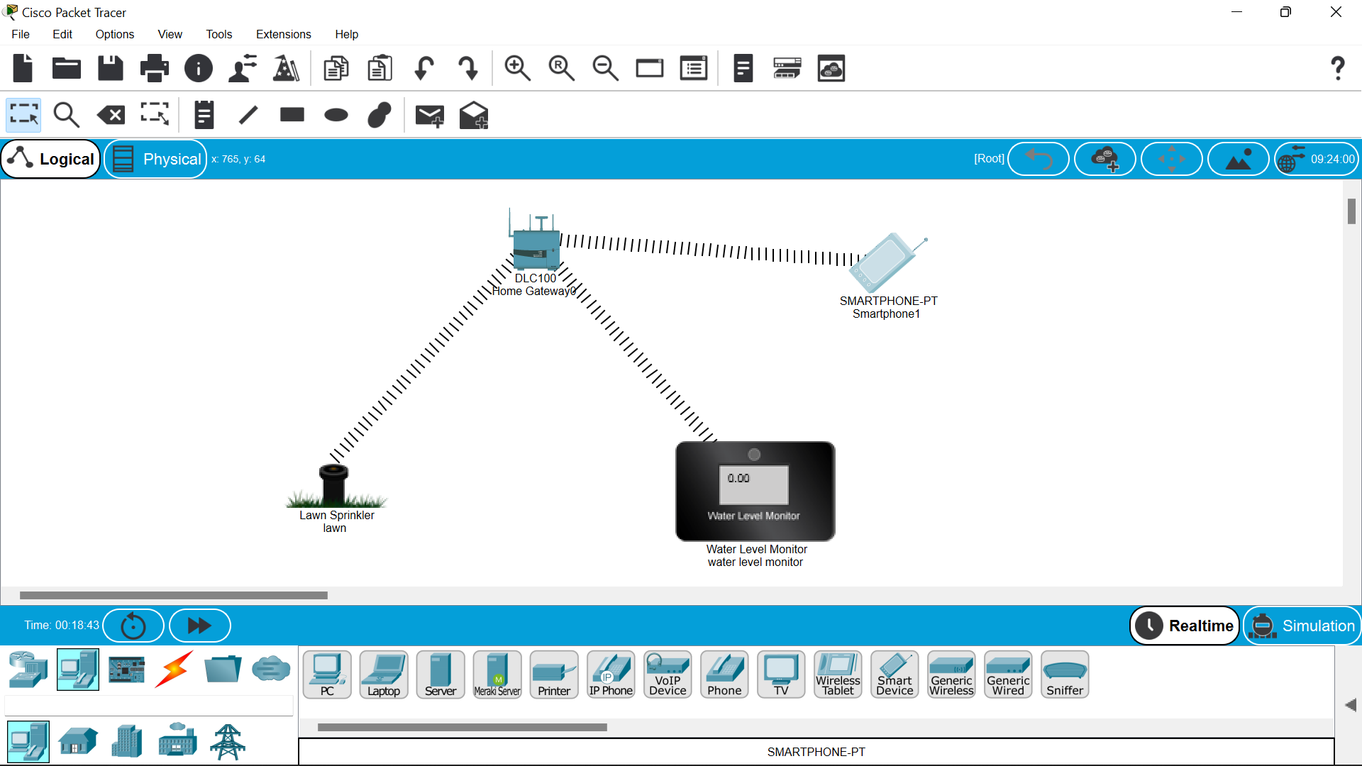

9.then click on the smart phone open desktop –iot monitor—login.

10.then you will find switches of lawn sprinkler and the waterlevel monitor is also displayed but it will run automatically when ever we switch on the lawn sprinkler .

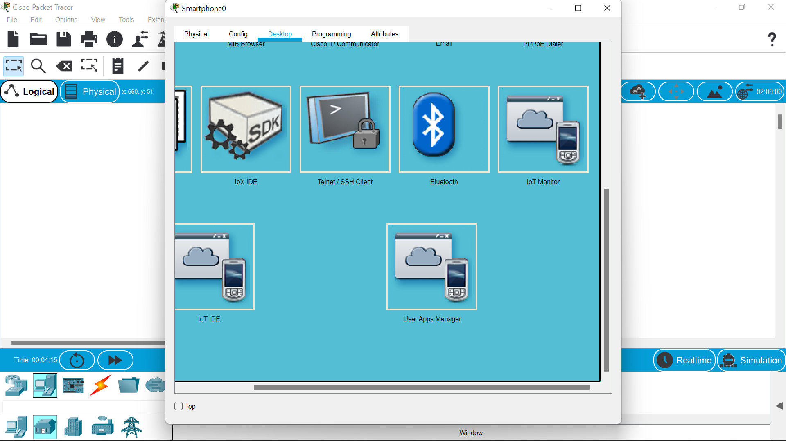

11.below are the switches to access the lawn sprinkler by which automatically the water level monitor will also be turned on.

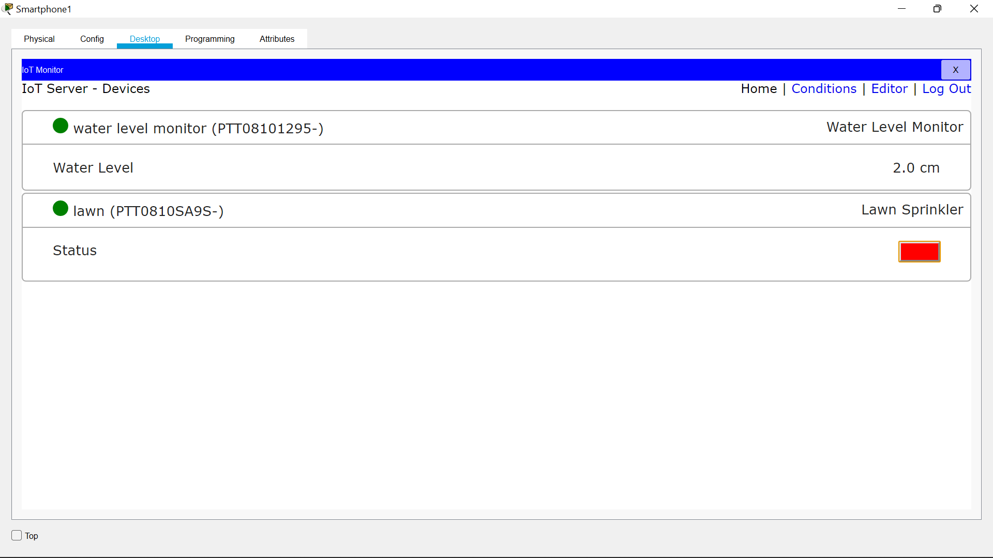

12.finally the lawn will be sprinkilling the water as in a garden.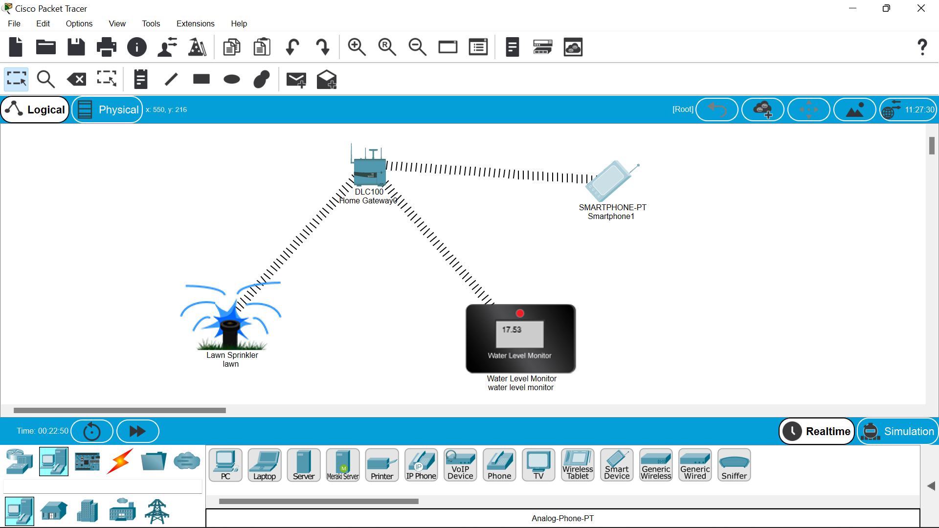

RESULT::

There fore the smart garden has been designed by the cisco packet racer successfully……..

**EXPERIMENT NO –15:**

**MAKE COMPUTER LAB DESIGN IN CISCO PACKET TRACER.**

**AIM:**

**The main aim is to build an computer lab design.**

**Materials required::**

Cisco packet tracer,pc’s,server,switch.

PROCERURE::

1.Open the packet tracer.

2.Get the switch from net work devices and 4 pc’s ,including the server.

3.Put 4 pcs in order vertically ,then copy them vertically and paste them side by

Side to get 20 pc’s at least(assuming that a computer lab might be having the at least 20 pc’s).as below.

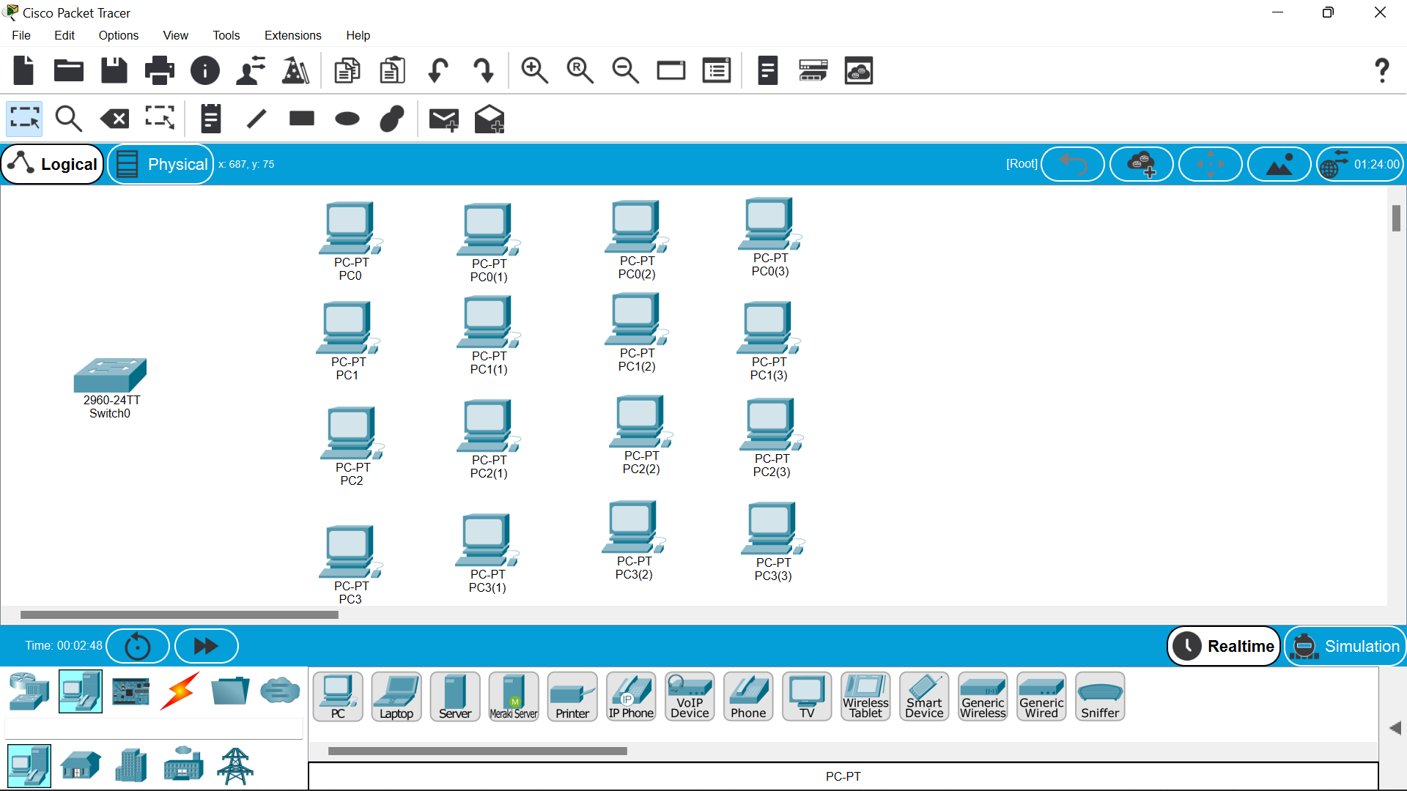

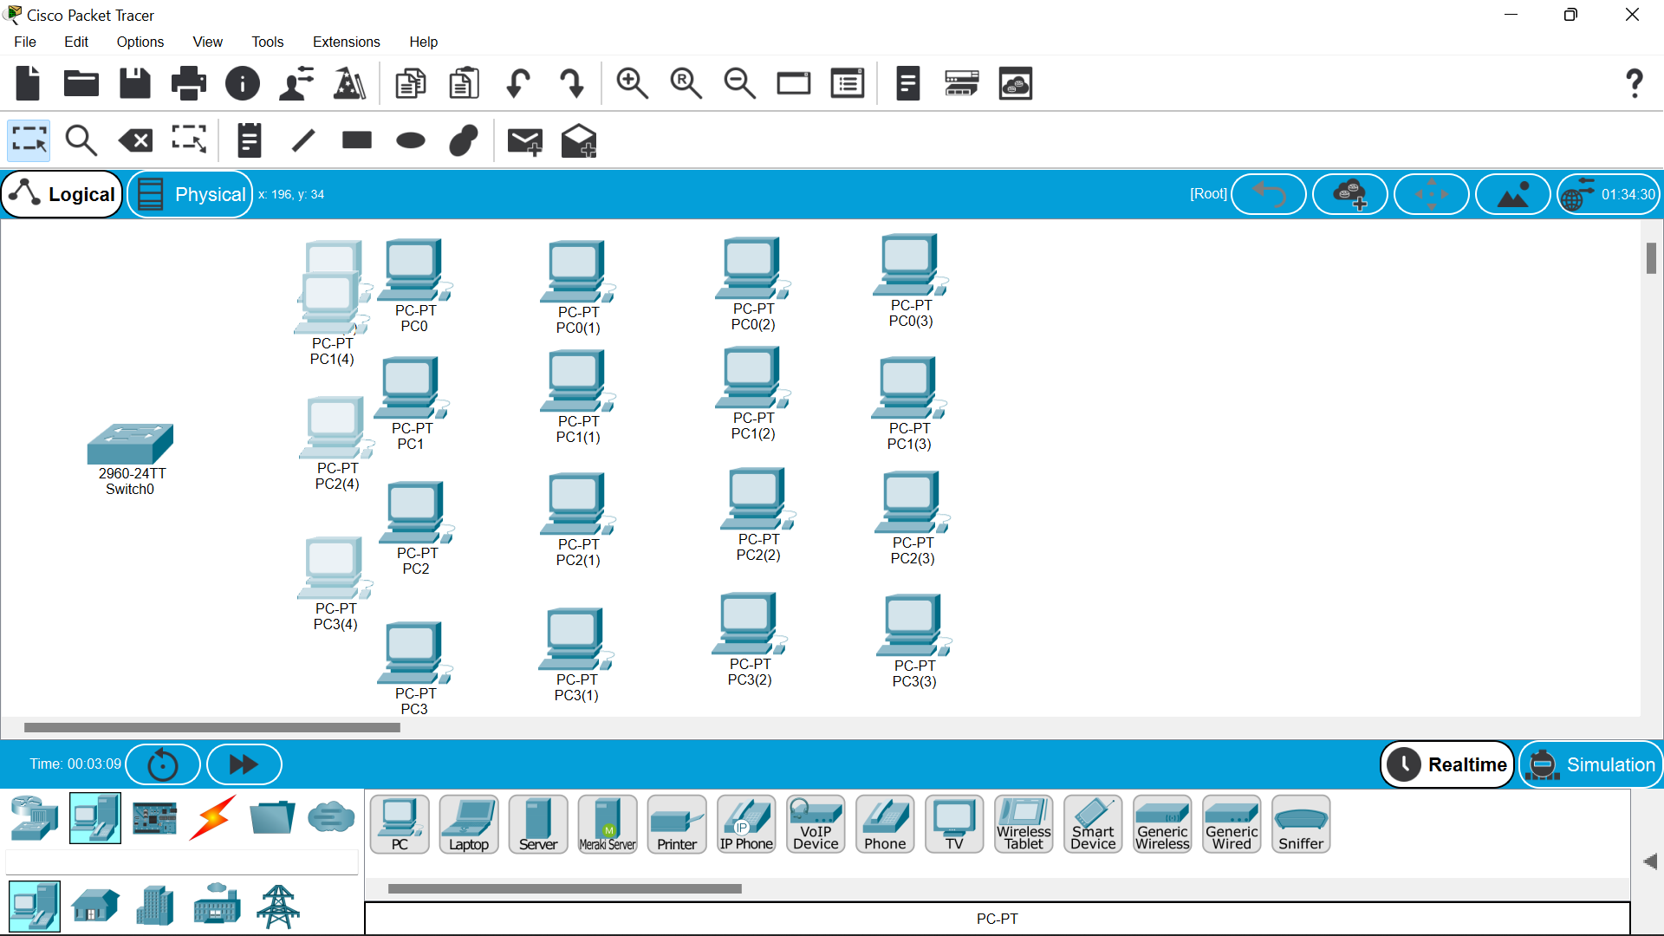

4.Then establish the connection between the switch and pc’s respectively and also between the switch and the server.

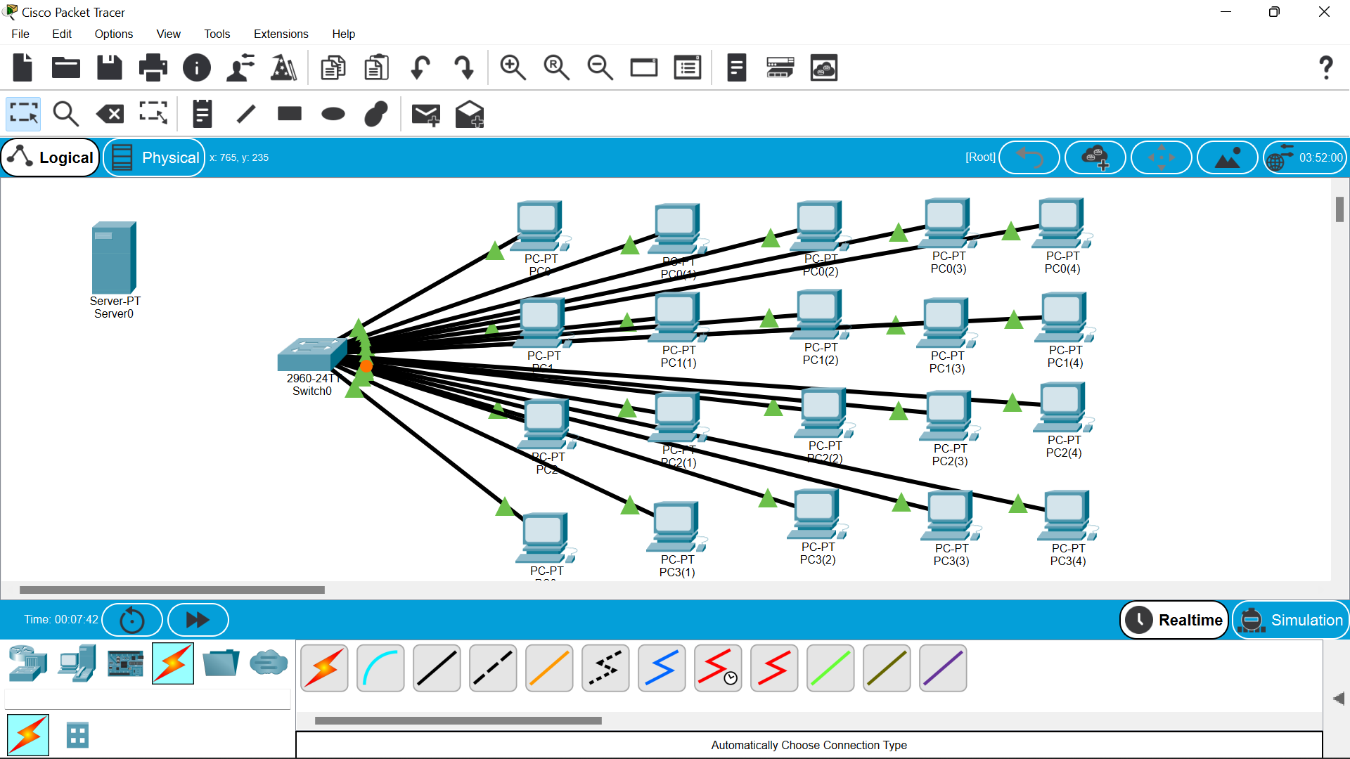

5.Also connect to the serever then ,click on the server –desktop—ip configuration.give google dns in it i.e 8.8.8.8.

6.Then enter the ip address also.

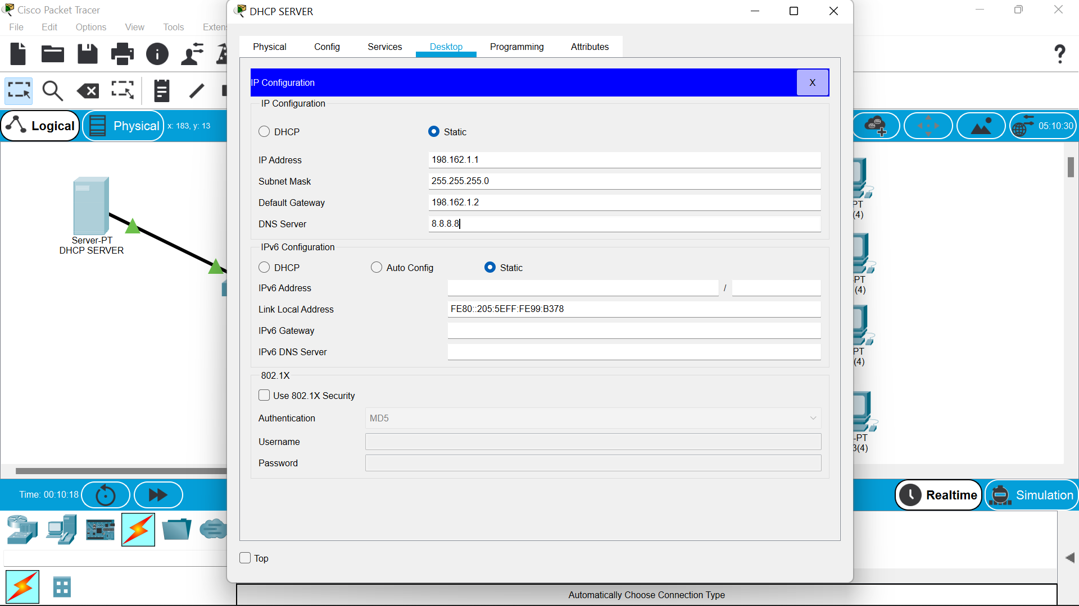

7.Go to the services DHCP—click—turn on—gateway ip—DNS as google server address—and start ip address of pc’s (just change the last decimal as below.

8.Then save the changes.

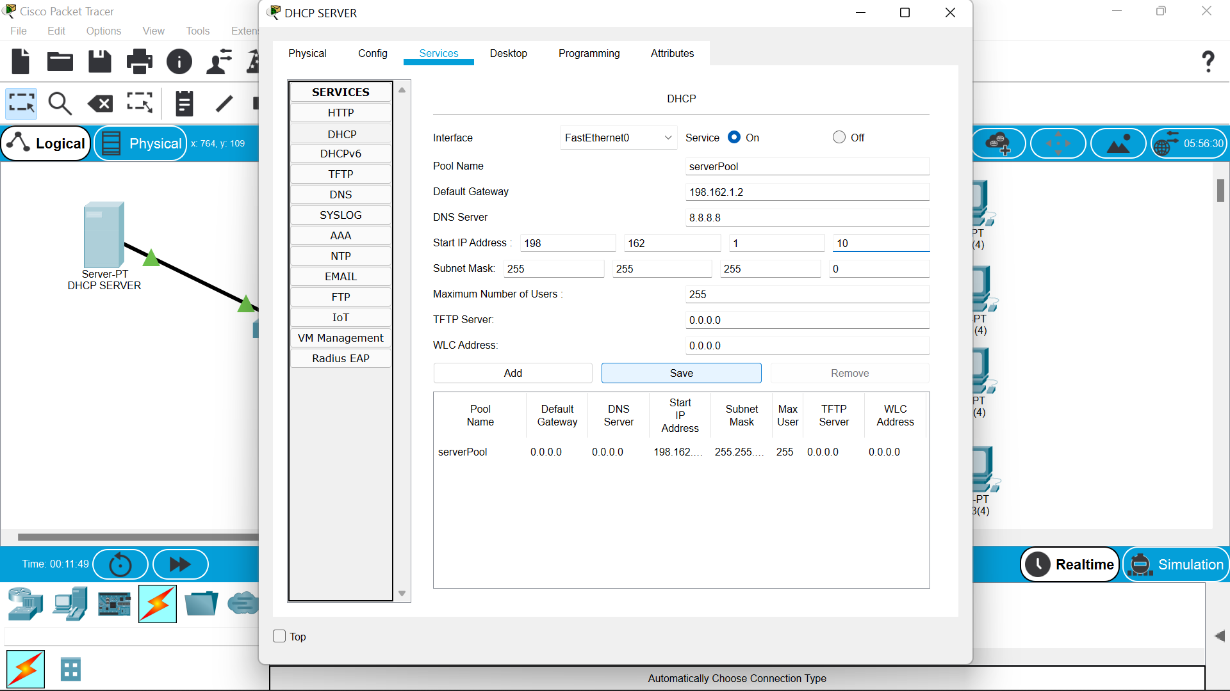

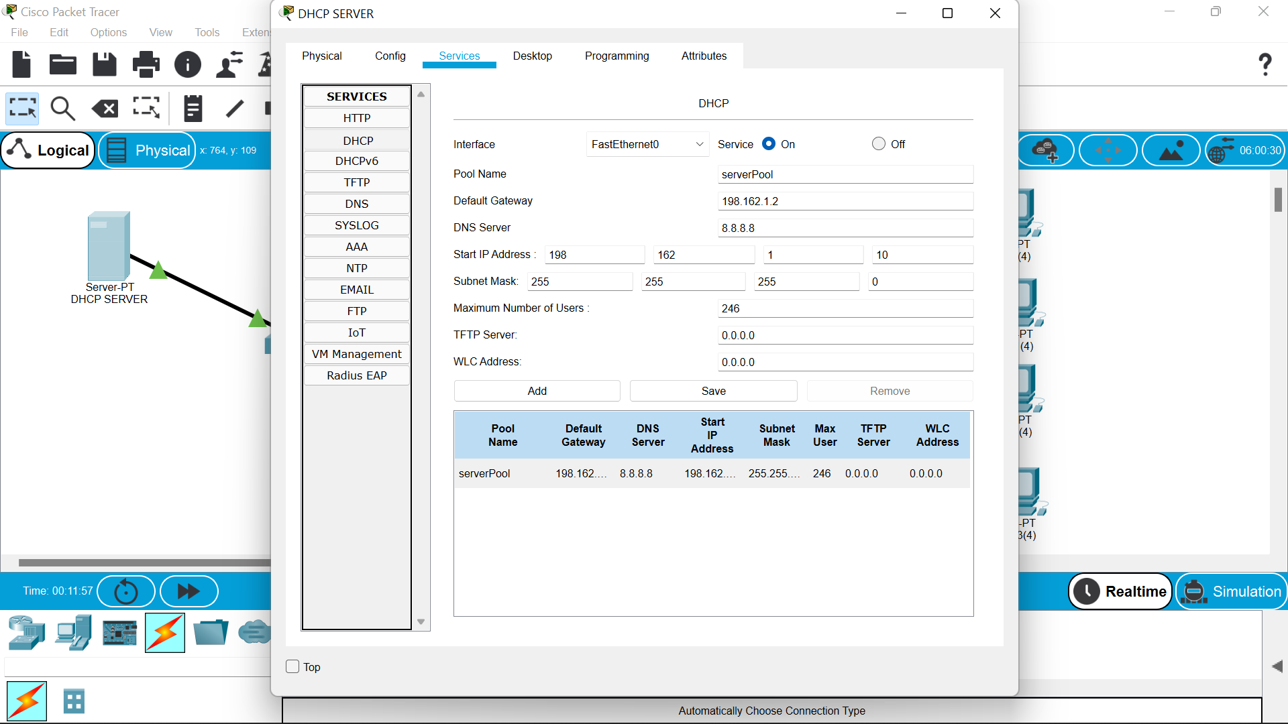

9.Now move on to the pc and go to the ip address option ,on the top you will find the DHCP click on it.

10.Now the ip address and other dns every thing will be filled automatically.

Continue this for all the 20 pc’s.

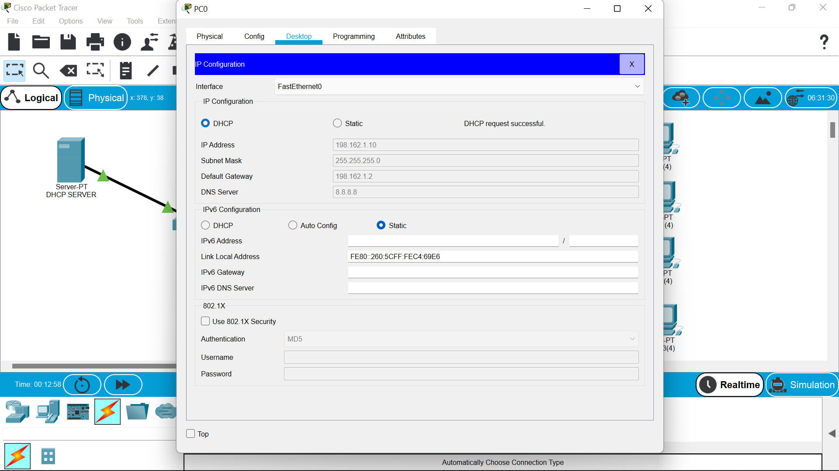

11.After this you check to transfer the message from on pc to other.

12.And we can try to run it in stimulation to view the path of the message packet.

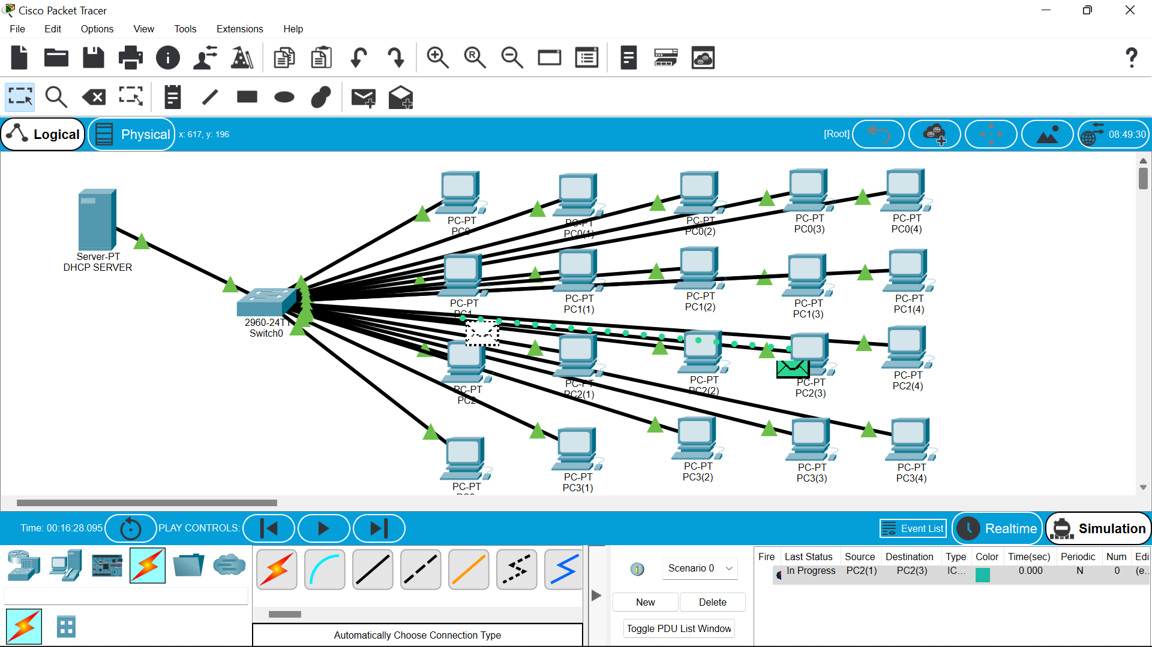

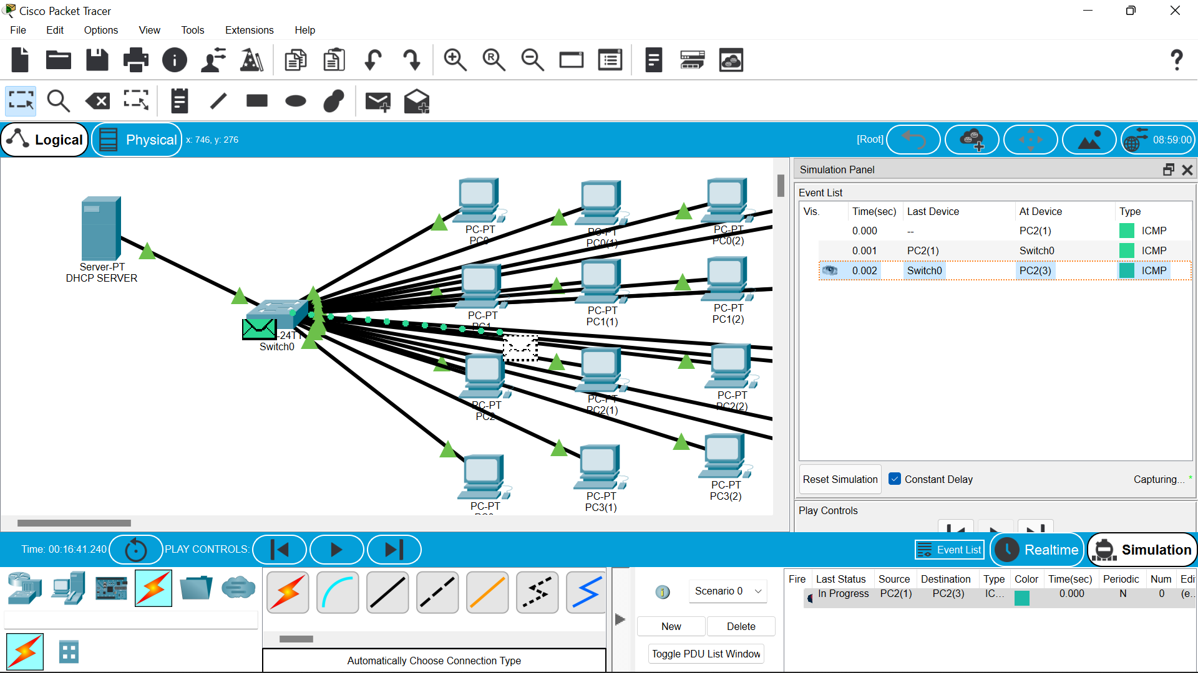

RESULT::

so finally we have successfully constructed the computer lab using cisco packet tracer ...

**EXPERIMENT NO –20,13::**

**controlling fan ,light &applications of cisco tracer.**

**AIM:**

**controlling fan ,light &applications of cisco tracer.**

**Materials required:: Cisco tracer software.**

Procedure ::

1.open the cisco tracer .

2.Then ,network devices-wireless devices-homegateway and place it on the site.

3.then ,end devices—home—celing fan -and windows and light other home appliences.

4.then set them as bellow

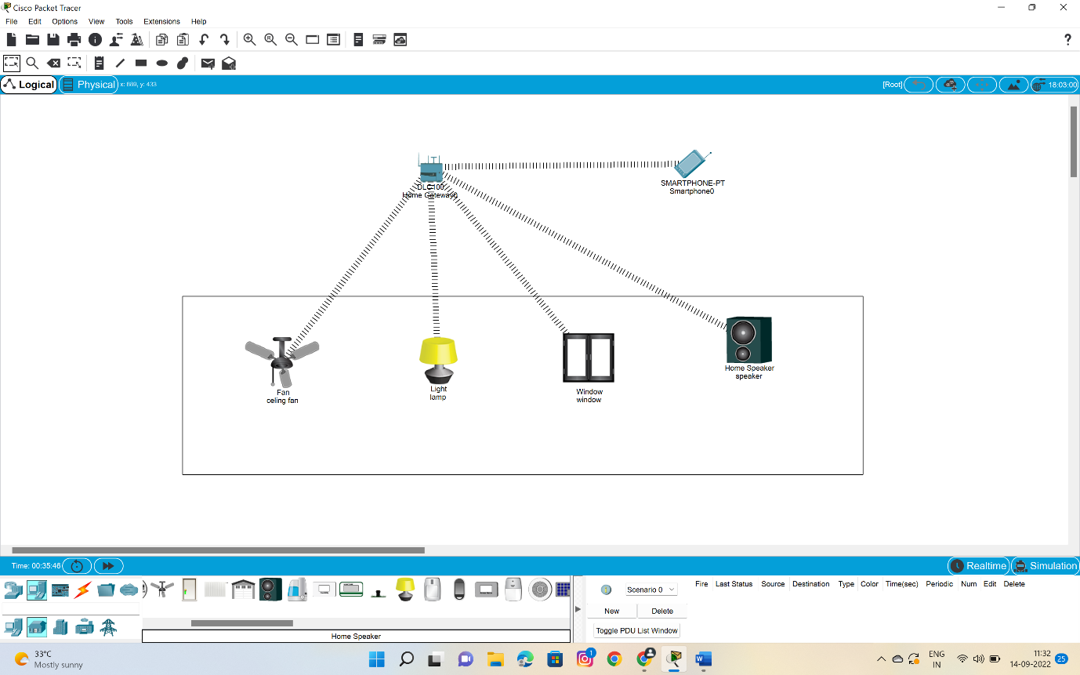

5.Then click on the fan -i/o configure –choose the wireless –then configr and wireless0 .repeat the same to the window,and lamp also.the the dotted lines will be formed btwn the homegatway and fan and window



6.Then move to the end devices –click the smartphone to operate the wireless devices.

7.click on the smart phone to configure with homegateway give “HomeGateway” in the ssid space in wireless0.

8.connetion is established.



9.then click on the smart phone open desktop –iot monitor—login .

10.then you will find switches of celing fan and the window switches along with lamp switch .

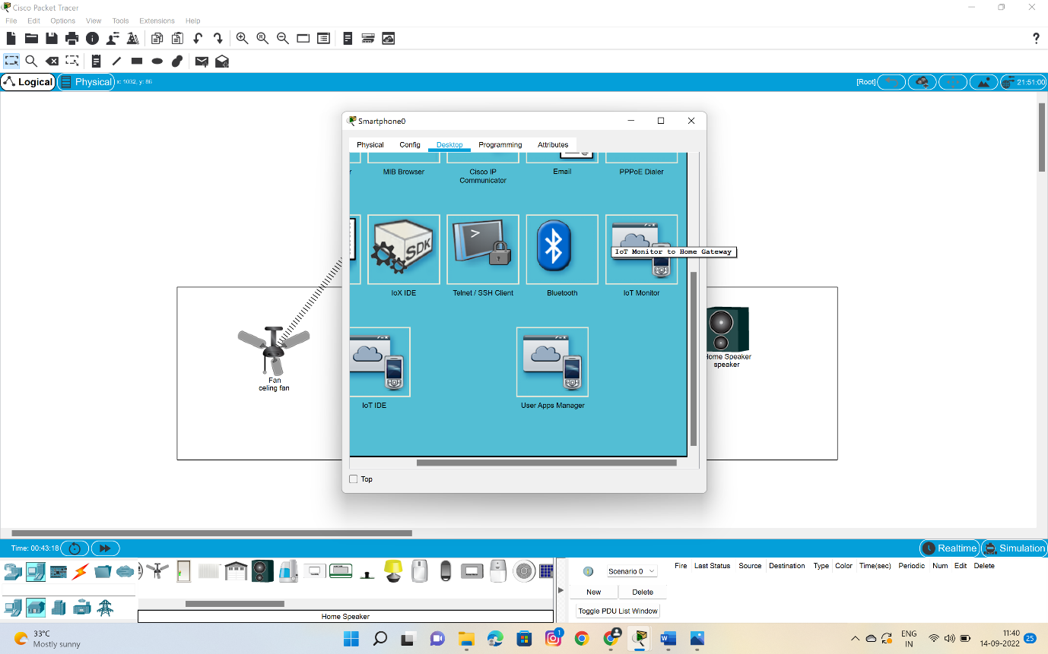

11.below are the switches to access the fan ,window,lamp and speaker too.

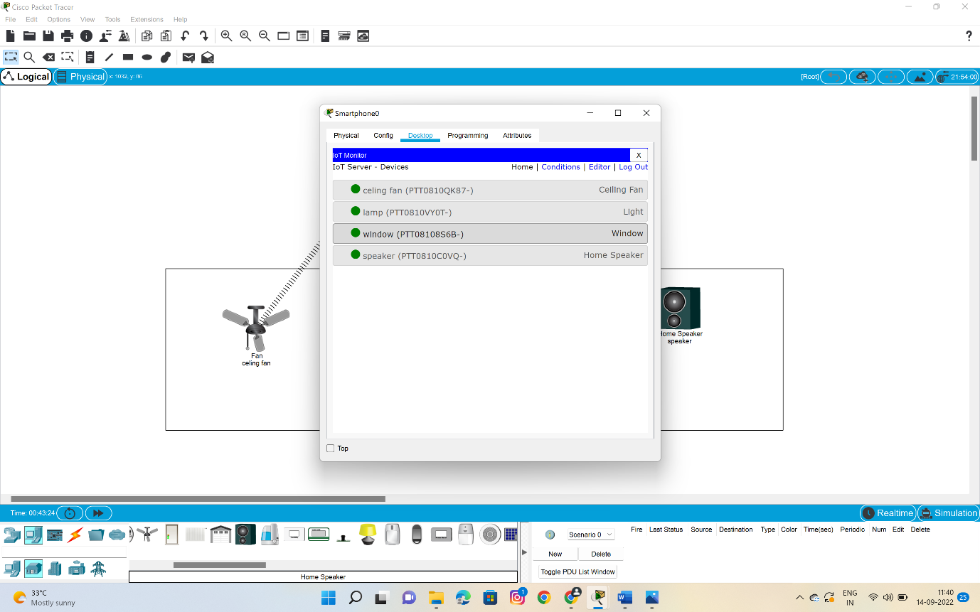

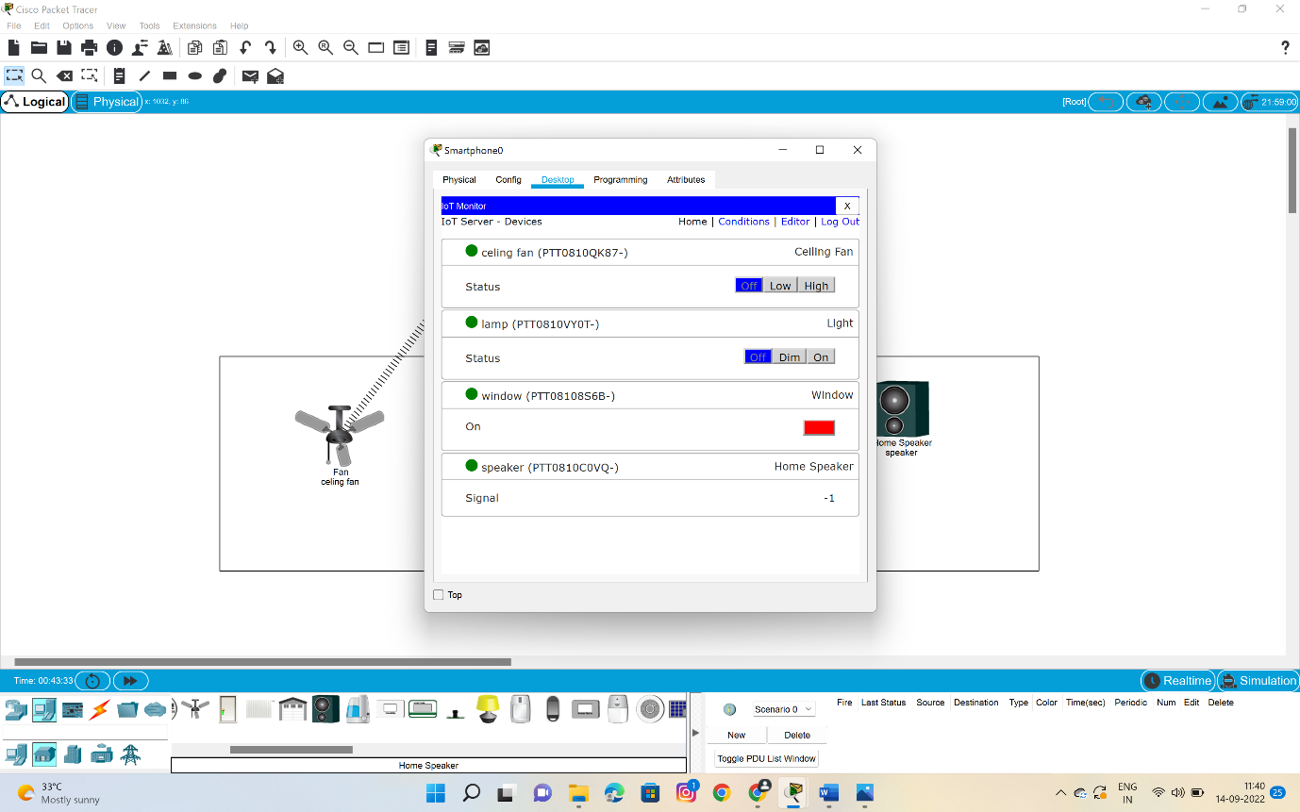

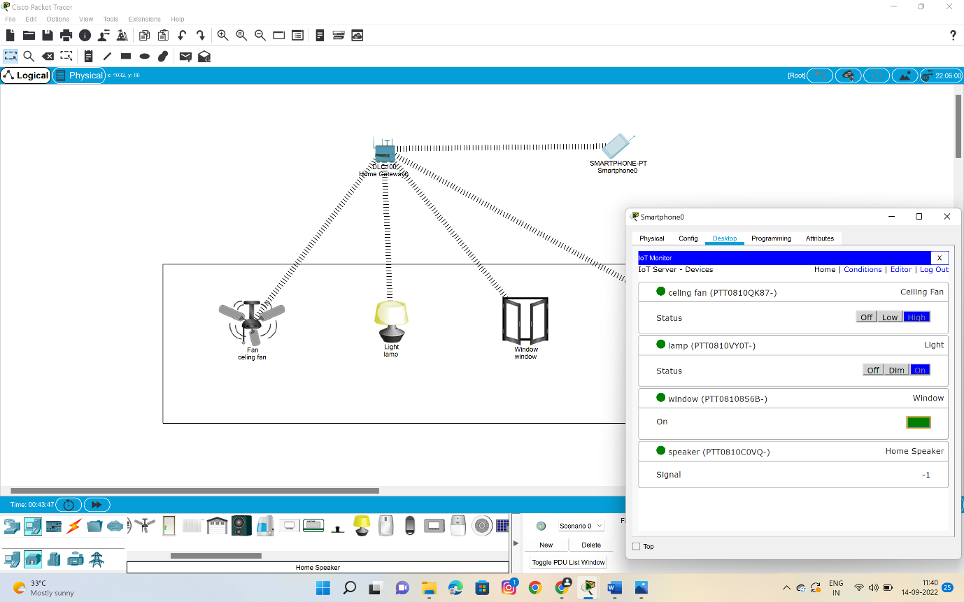

**12.In this picture we will be able to find that all the appliences are working .**

RESULT::

So successfully we have done an experiment for controlling the fan switch ,window and additionally we have added the speaker also……